# Work Queues

Work Queues are the list of items from which one or more bots can take input from and process. And these items are called cases in blueprism terminologies.

Let us take an example-

If you have a excel file contain 10,000 records. And blueprism takes 10 sec to process each record lets say each record for currency conversion. Then it would take around 100,000 sec (28 hrs) to process complete file hence if more than one bot is performing this operation lets say 7 bots then time would be divided and process would complete in 4 hrs. Here each bot will take input from excel file and process that, called case and this is called work queue.

Work Queue allows using multiple machine and allowing monitoring status of each case. Generate MIS report with information like volume, performance, exception details etc. Also the individual cases marked as completed or exception so that later on you can run the cases those was failed/exception.

**How to implement work queue?**

In order to implement work queue lets first import a very important object called collection manipulation in Studio from the list of VBO blueprism provided by default.

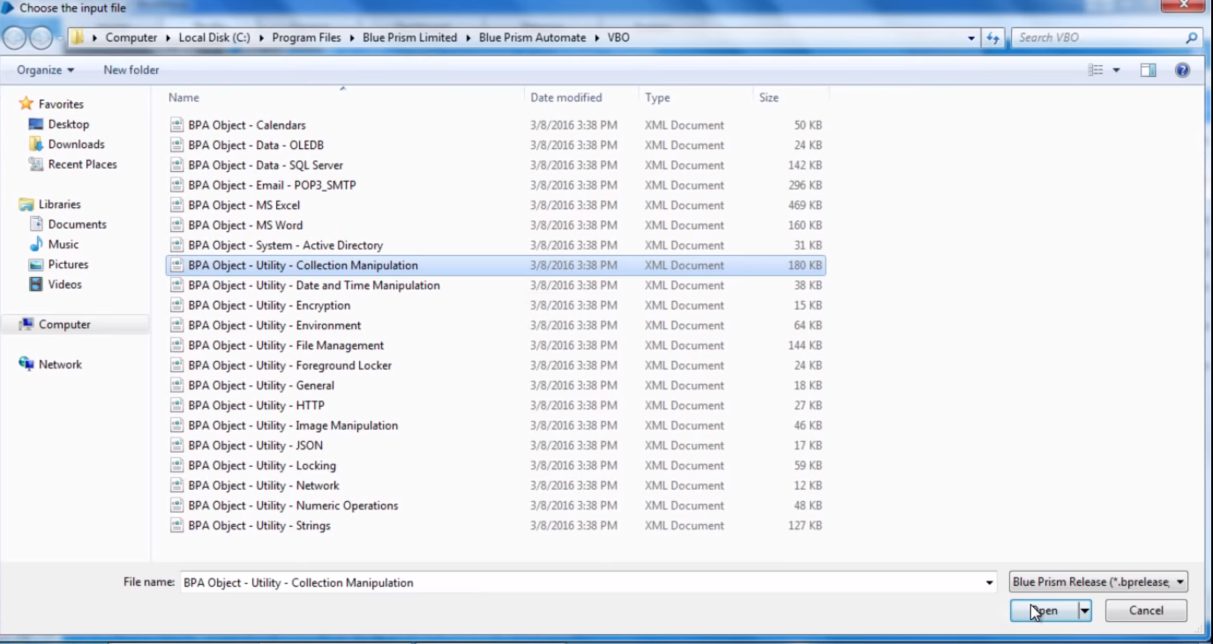

Now as we have imported the collection manipulation VBO so we would be able to perform task such as copy collection, append into collection etc.

Let us create an example for Work Queue –

This is our excel file –

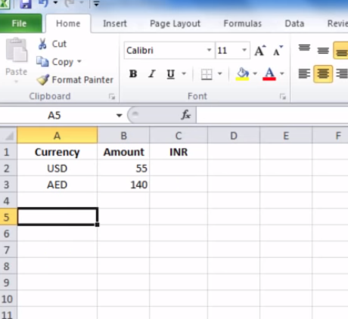

We need to read values of Currency and amount from here and Launch a website called currency converter and convert the values and amount to the INR and update this file.

Below is the current process we have from excel automation in blue prism –

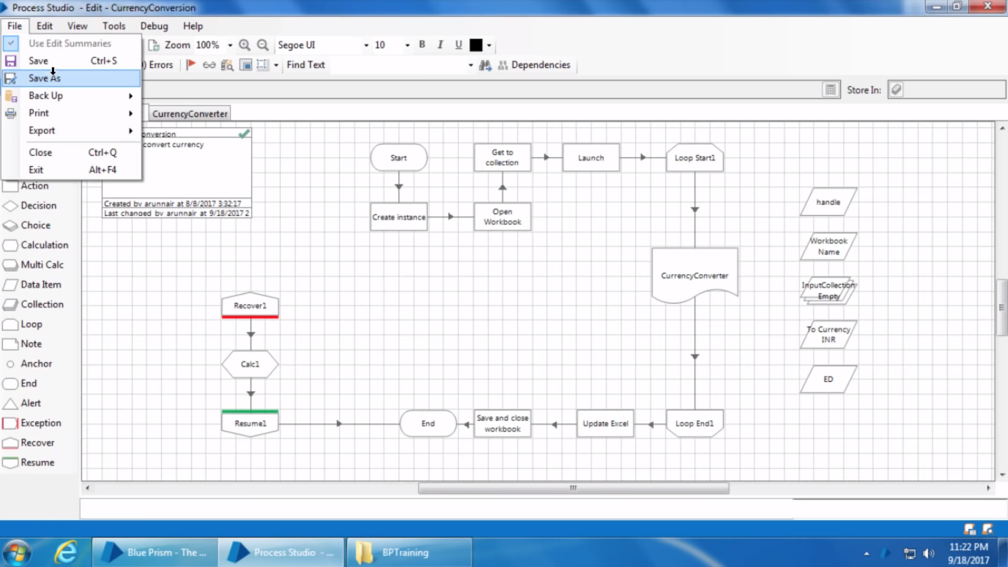

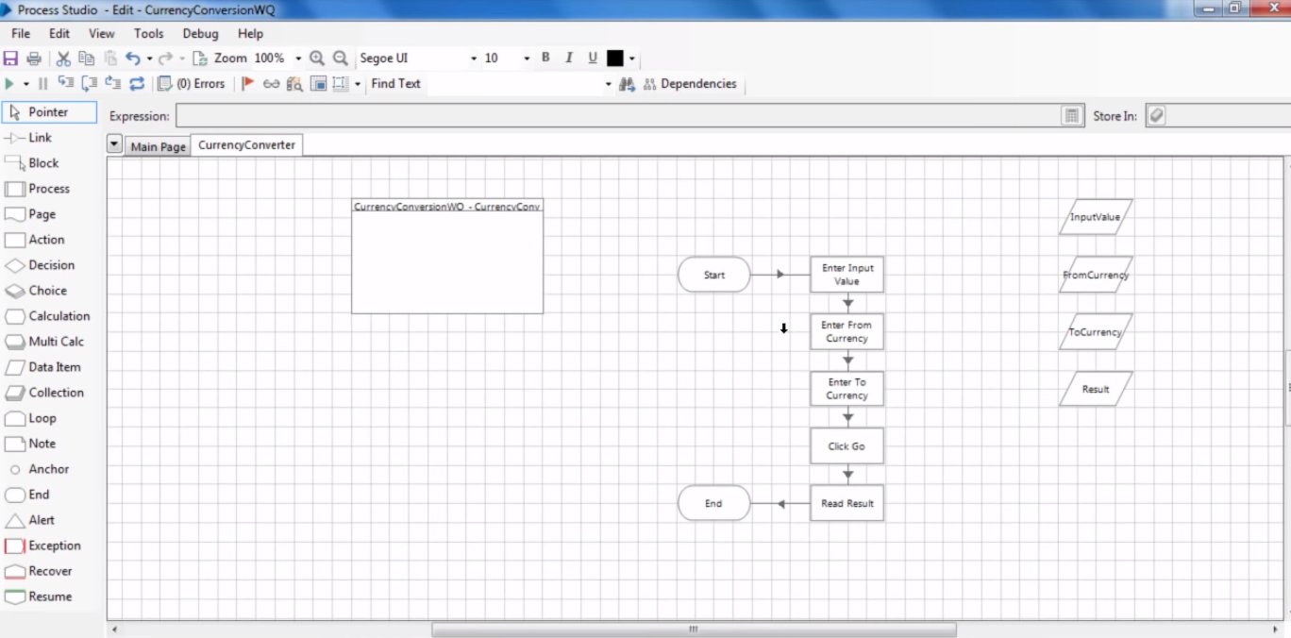

Now when we implement work queue then we don’t need this loop to loop through instead we load the data from collection to Work Queue and then we perform action based on the data returned from that queue.

So let’s just first create a queue so that can be used under this process.

To Create Queue go to System Tab > Workflow > Work Queue and give Queue name and click apply.

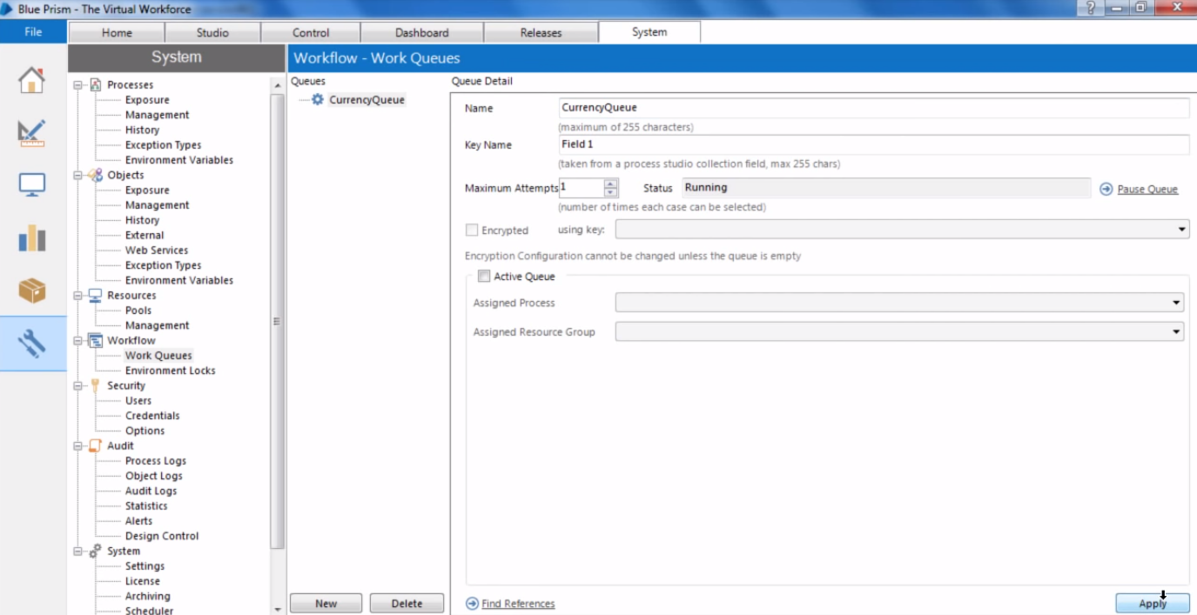

Now go back to process studio and delete loop stages, add an action stage instead as given below, open it, and select Work Queue in Business Object and Add to Queue in Actions field.

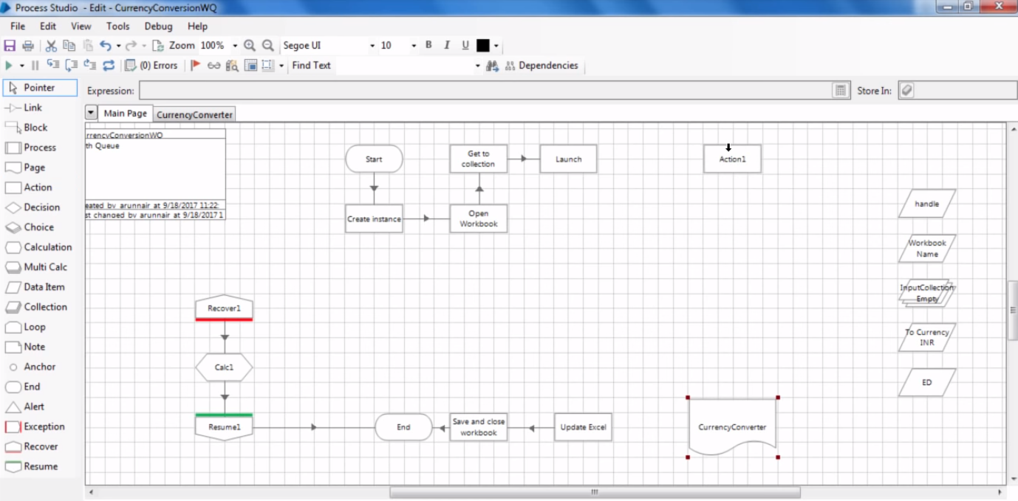

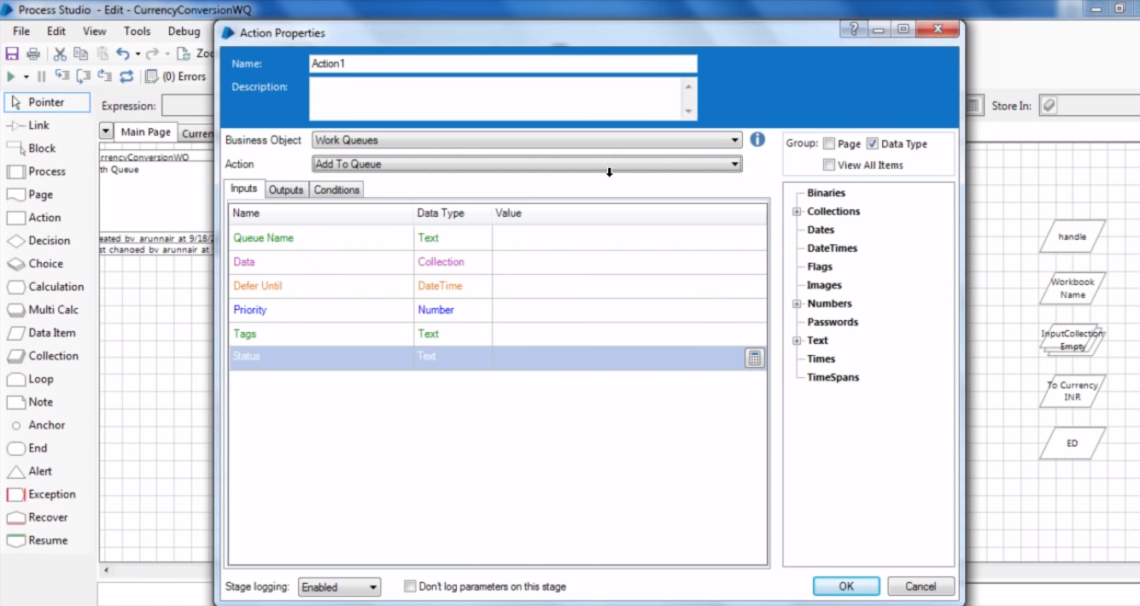

Add to Queue simply add a collection to a queue.

Enter following properties in the dialog –

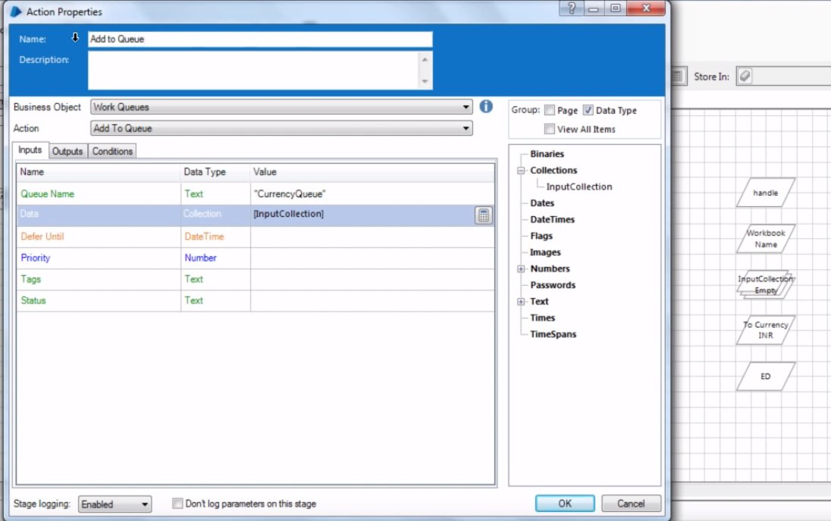

Queue Name to the name of the queue created in System Tab. And Input collection from where data needs to be inserted in the Work Queue.

In output parameter – as blank for now.

Named this action as **Add to Queue.**

Now if we join this action to Currency Converter Stage and run it then in Control Room in Queues we can see that the data is been filled in the queue.

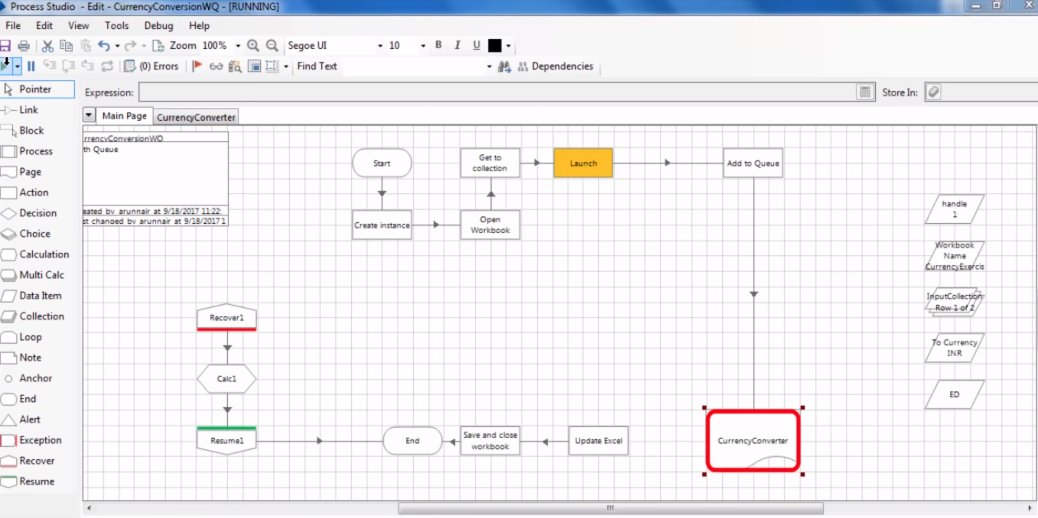

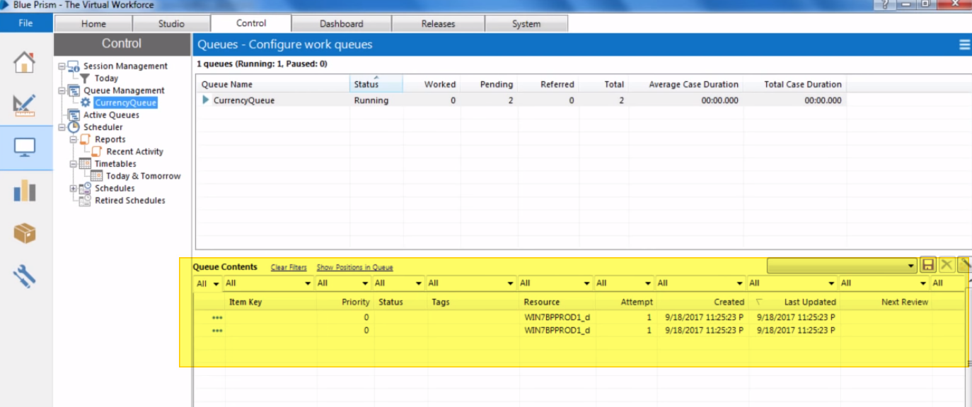

Now to read data one by one from the Work Queue add an action stage and open its properties–

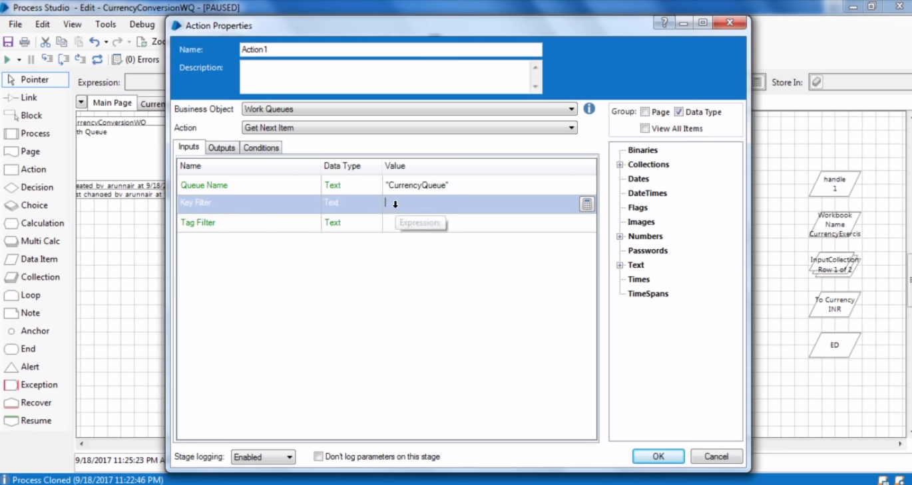

Business Object- Work Queue

Actions – Get Next Item to get next items from work queue.

Input Para –

* Queue Name – Name of the Queue in double quotes. “CurrencyQueue” in this case.

Keep rest of the fields blank and move to Output para.

Output Para-

* Item ID – When Data is inserted in work queue using collection then each record in work queue is been assigned with an item id which is been used later on.
* Data is the collection is been used to store data fetched here. So QueueData lets say for this.

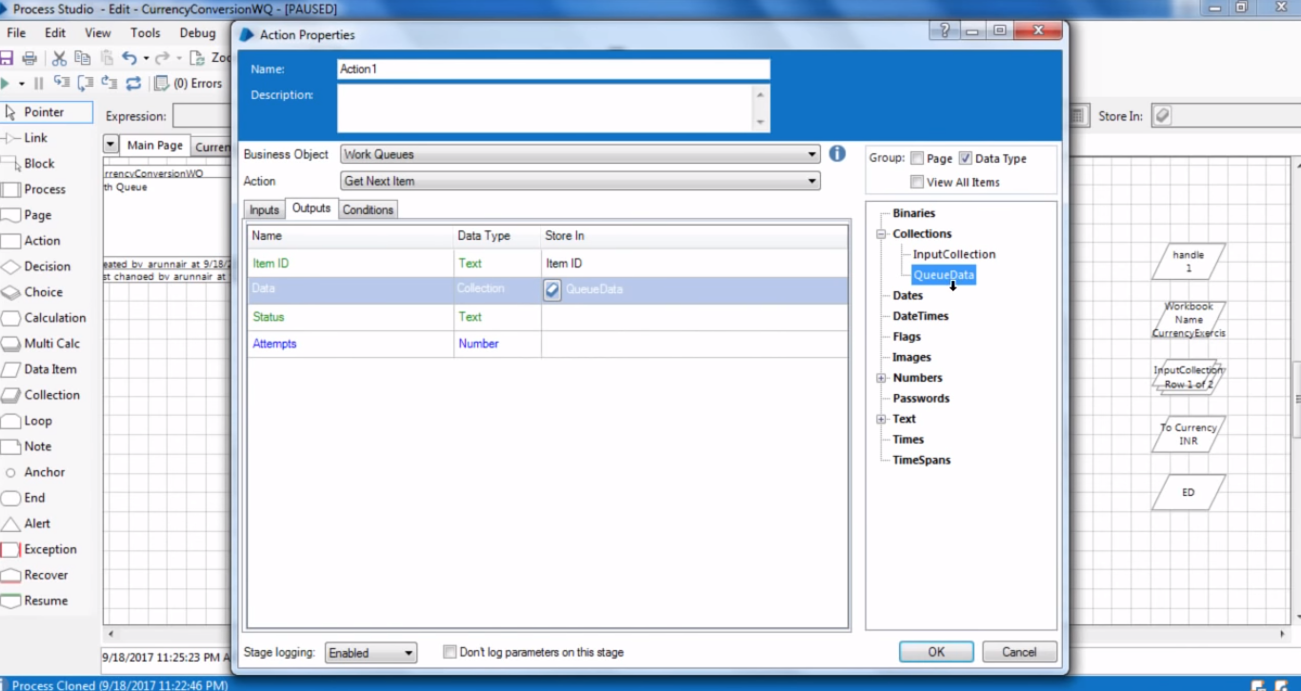

Finally, it looks like this –

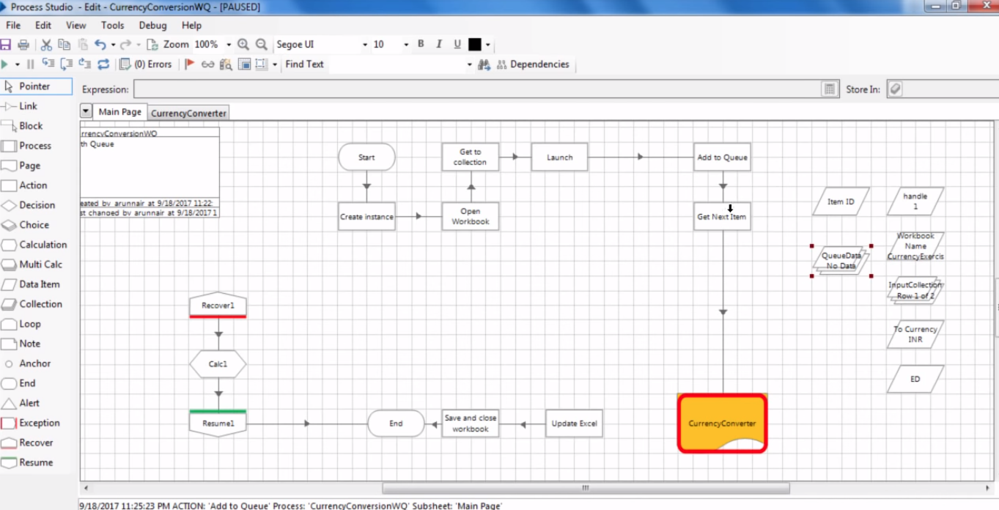

Now when we run it one-step at a time and see the Queue data is been filled with one row when we read one record.

As given in below figure.

Also when blue prism process one record then it lock that record for so that no other process or bot can use it until that record is being used in this process and bot.

This is primarily used in multi-bot architecture.

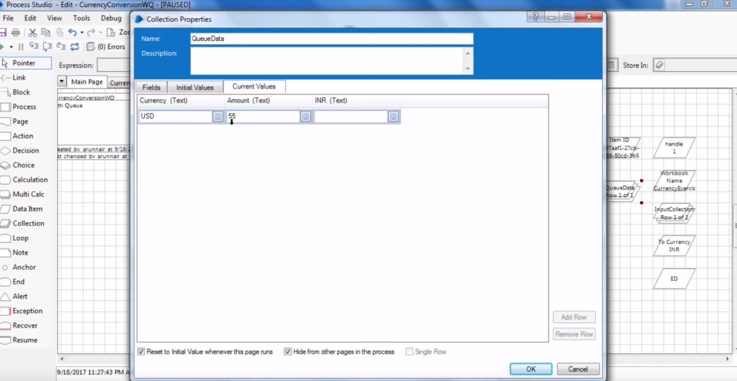

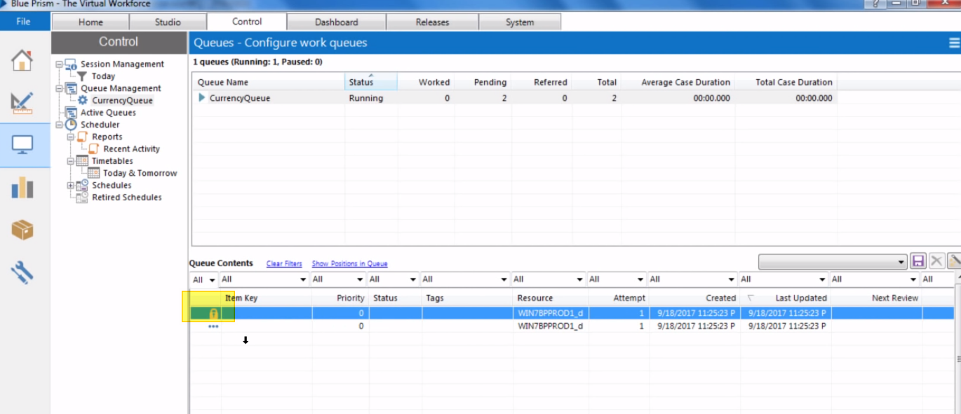

Now as we not working with loops anymore and need to supply values to currencyConverter Stage then we take QueueData collection instead of inputCollection. Hence we need to change the input and output parameters as given below in CurrencyConverter page reference stage.

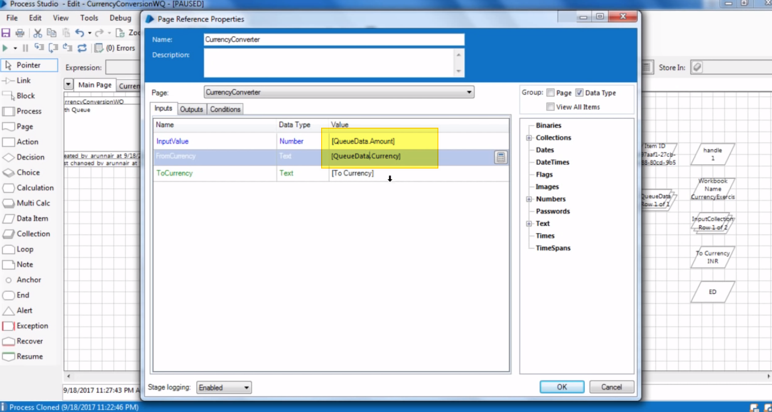

Here QueueData is the collection in which Set Next Stage Set Data.

Similarly for Output Parameters here as well

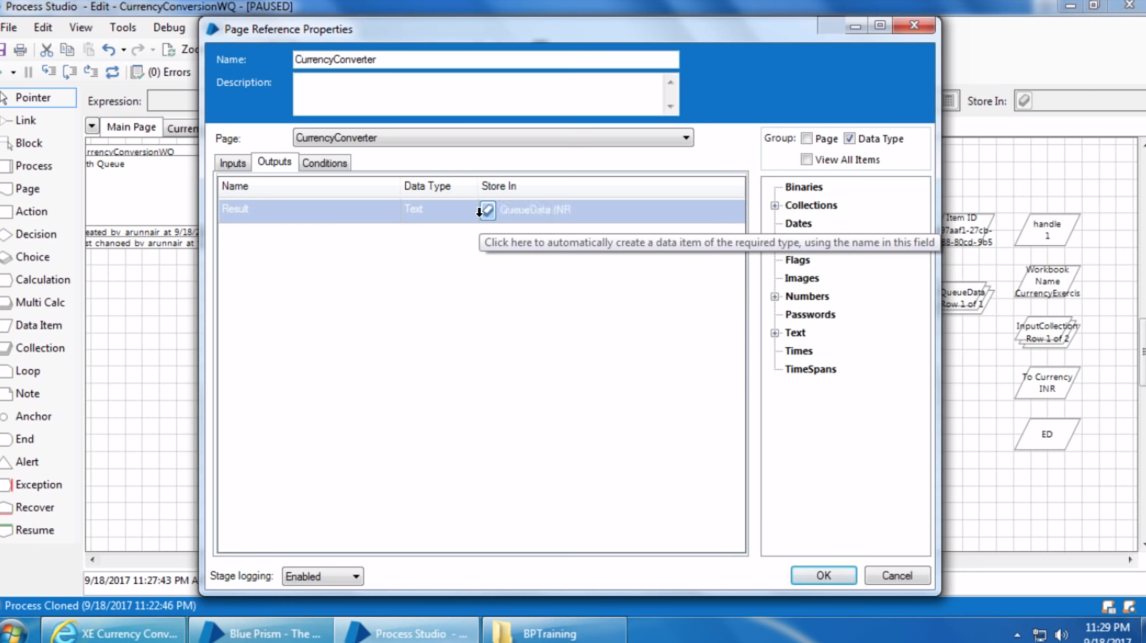

Collection name changed to QueueData

Now we have a problem here that when every time the get next data stage run it keep overwriting the QueueData collections with new values and old values are get removed.

Hence we need to store those values mean while somewhere else so that all values at final can be collected and can be write down to an excel file.

SO for that we use a new Collection to store those values. Collection as – OutputCollection.

Add a new Action stage and open it’s properties and fill out below details –

Business Object- Utility Collection Manipulation.

Action – Append Rows to Collection.

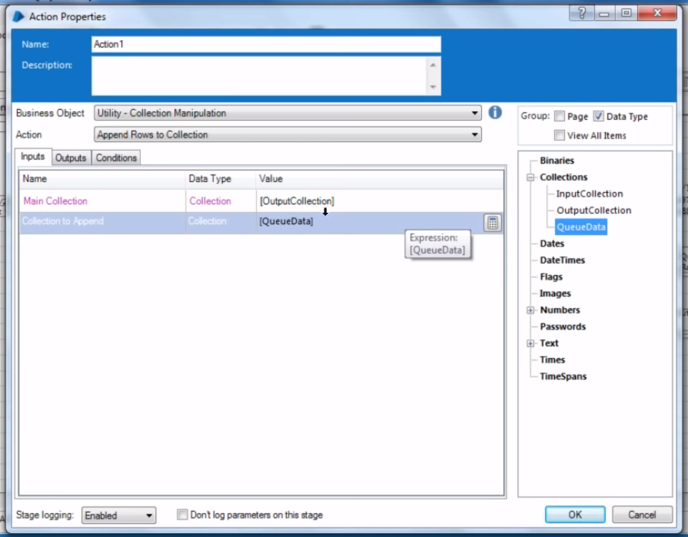

Here Main Collection is the destination collection to which data needs to be appended. And Collection to Append is the collection from where data needs to be read to append in dest collection.

Output para – specify the name of the combined collection that may be a new collection or an existing one.

As in our case it’s existing one that is output collection.

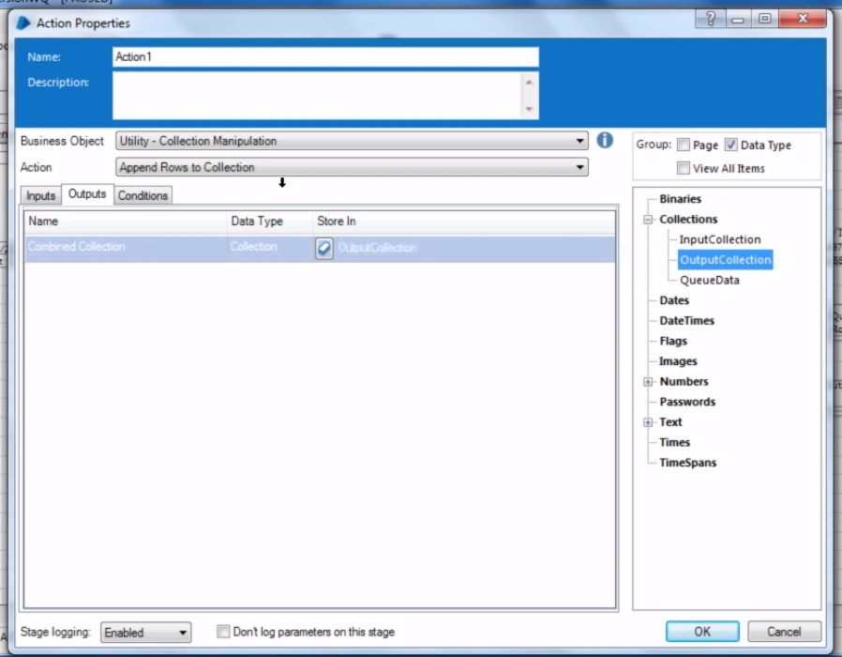

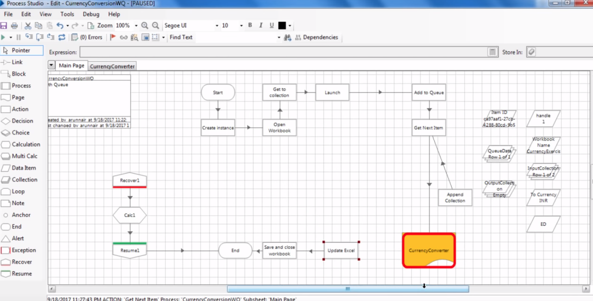

Now update the same in Update Excel Stage. Open it and update Input Collection with OutputCollection.

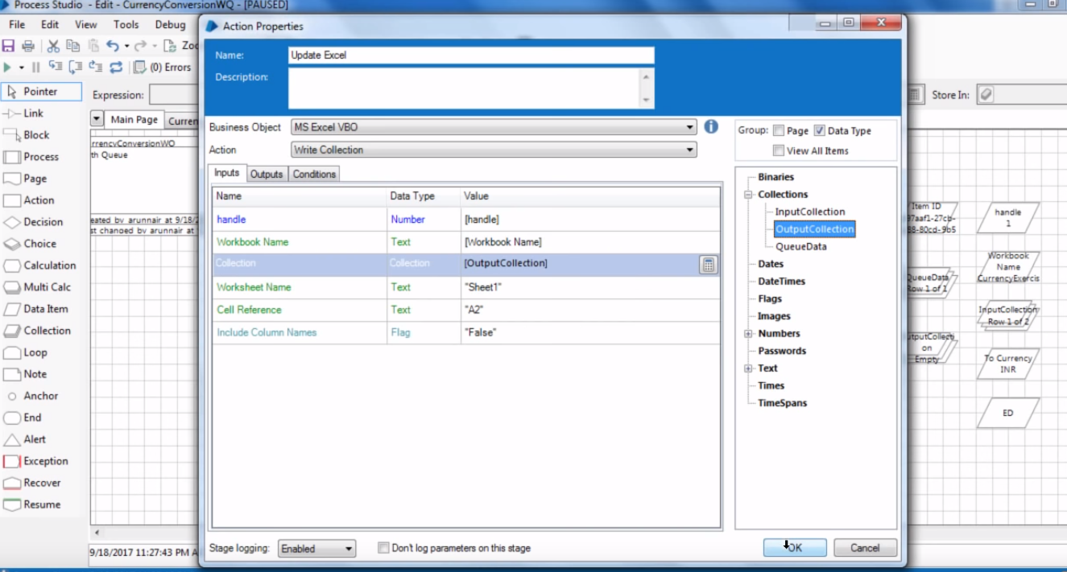

Now we need to connect stages with update excel stage but which stage should be connected. Whether Get Next Item, Currency converter or Append Collection stage ?

Well as when Get Next item will read all rows then it will not have any Item ID rest to show. Hence probably we can use a Decision shape here to check if the Get Next Item stage has any Item id next or if that is blank. Blank means no more items to process. So the setup would be like below –

Condition in decision stage –

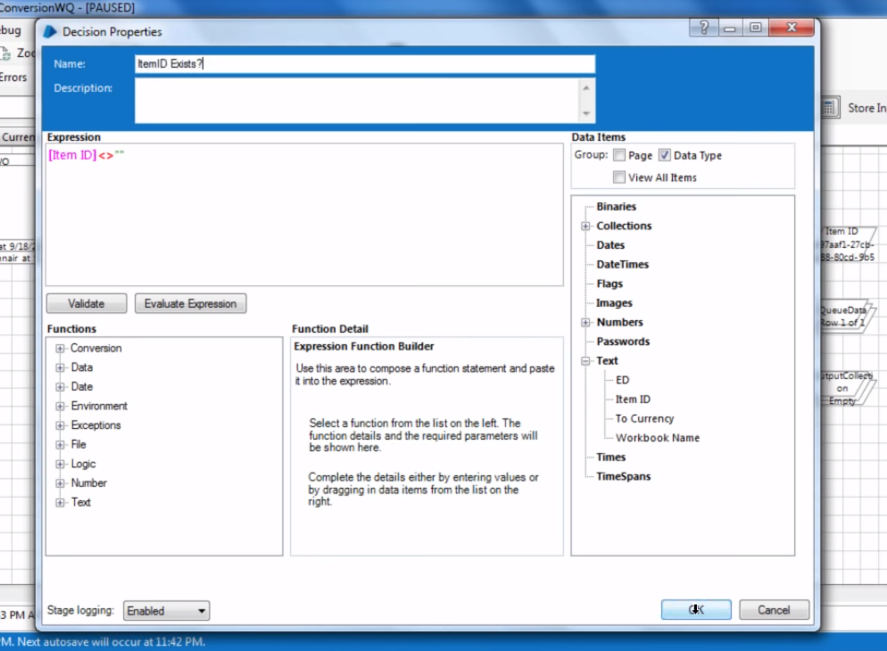

Final setup.

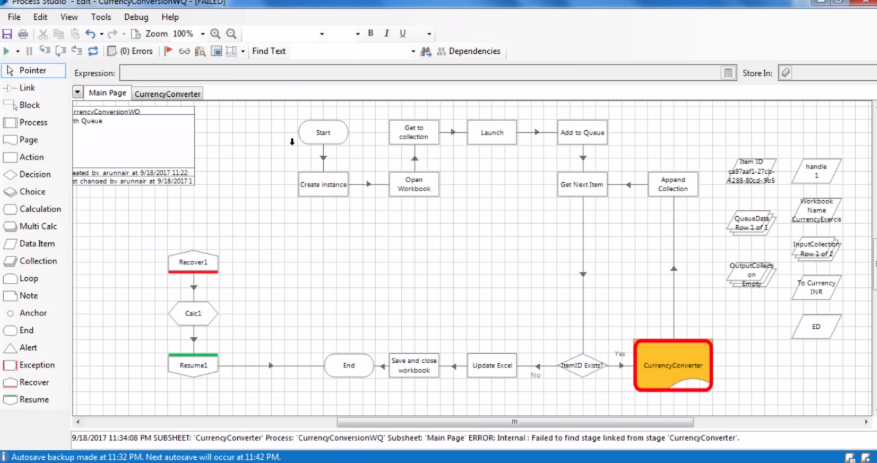

Now when we run it, it takes data one by one from Get Next Item stage and put that data to QueueData and Pass data from QueueData collection to Currency Converter stage and Get Output from currency converter and put that again in Queue Data. Now in Append Collection it takes data from QueueData collection and append that records in OutputCollection.

And for the next cycle of data Queue Data is blank and new values are filled in it from set next item stage and so on.

But now in this case when it is been run both and after completion check in queue control room the records in the queue are locked.

Because we have not passed any complete marker to it which say that hey! This record has been marked completed.

* 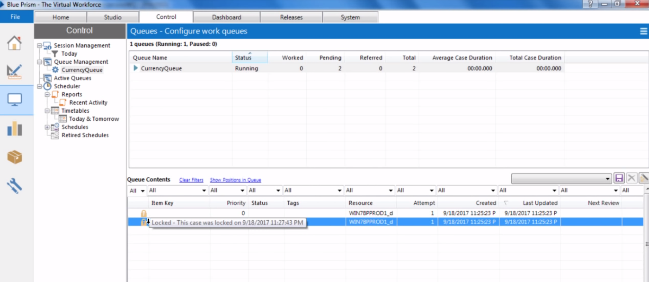

Now in order to mark it complete, we need to add one more action stage between append collection and get next item stage and open its properties and fill up below details –

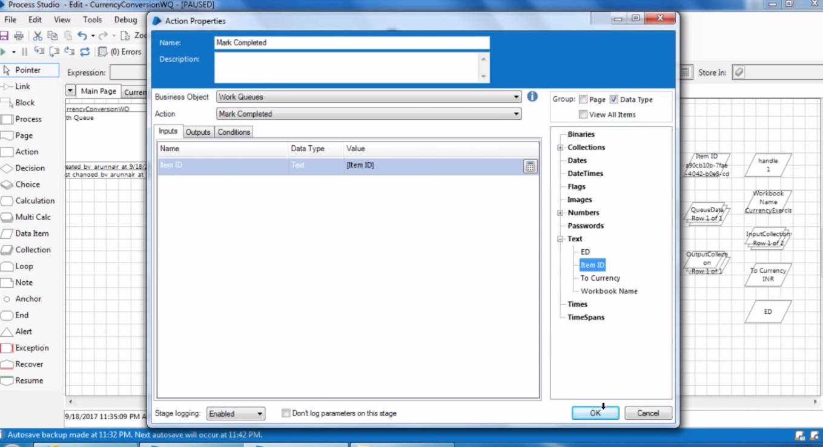



It takes in Item Id for the row to identify the row of Work queue been processed.

Final setup looks like –

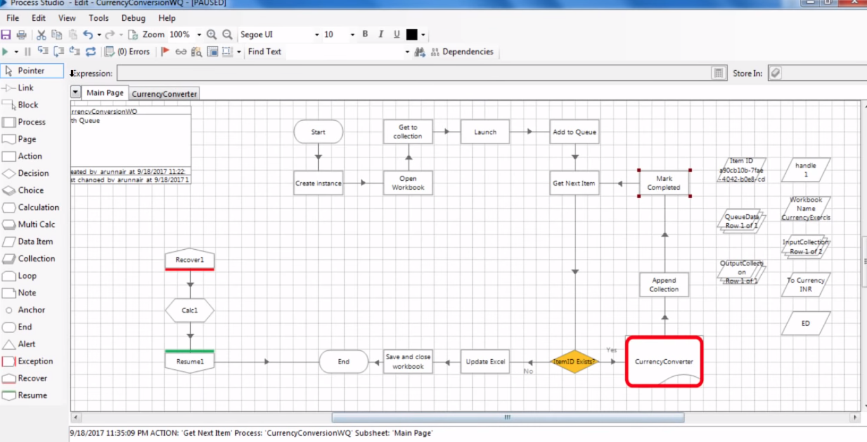

Now as now we run it then after using first row it mark it completed in control room queues –

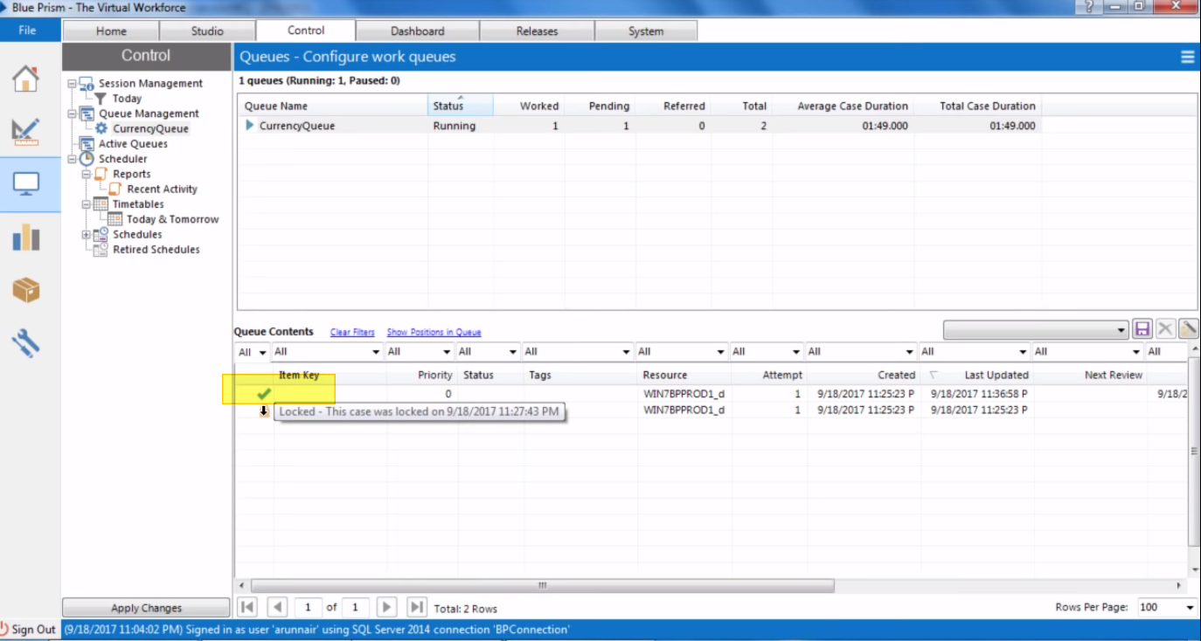

Now after processing all records from excel Output Collection get appended with all rows as below –

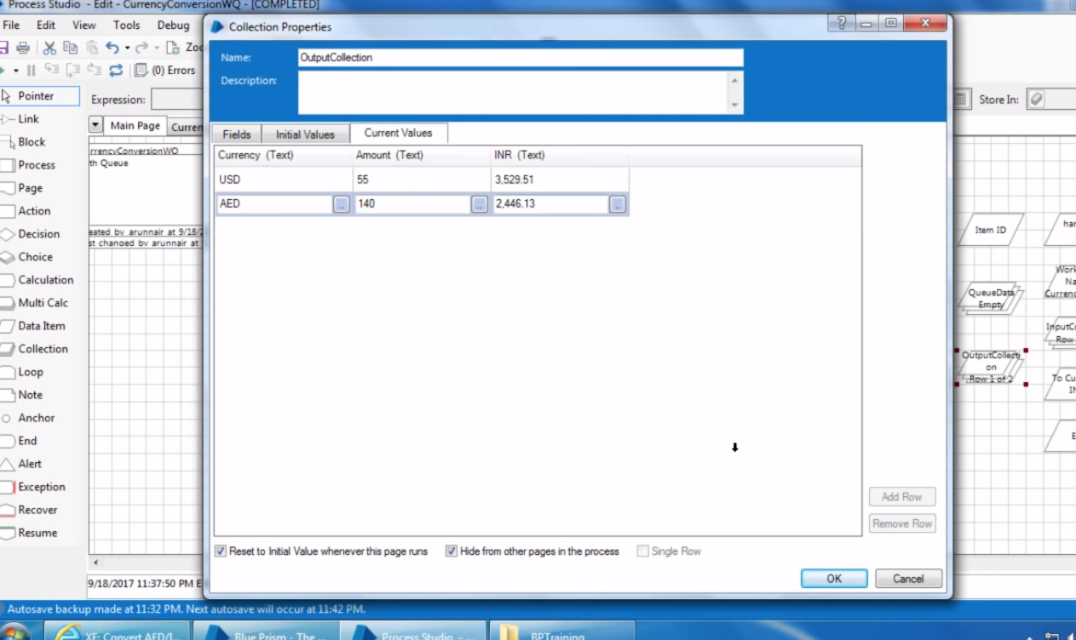

## Exceptional Handling in work Queue–

Now currently while processing records of the work queue if any exception comes then our process will be aborted and that exception would be catched by the recover stage. But what is we do not want to abort our process in case if it is unable to process any records and if there is any error/exception occur in any record then bot simply should not stop there and should move forward and continue to process other records.

Let’s make this kind of workflow.

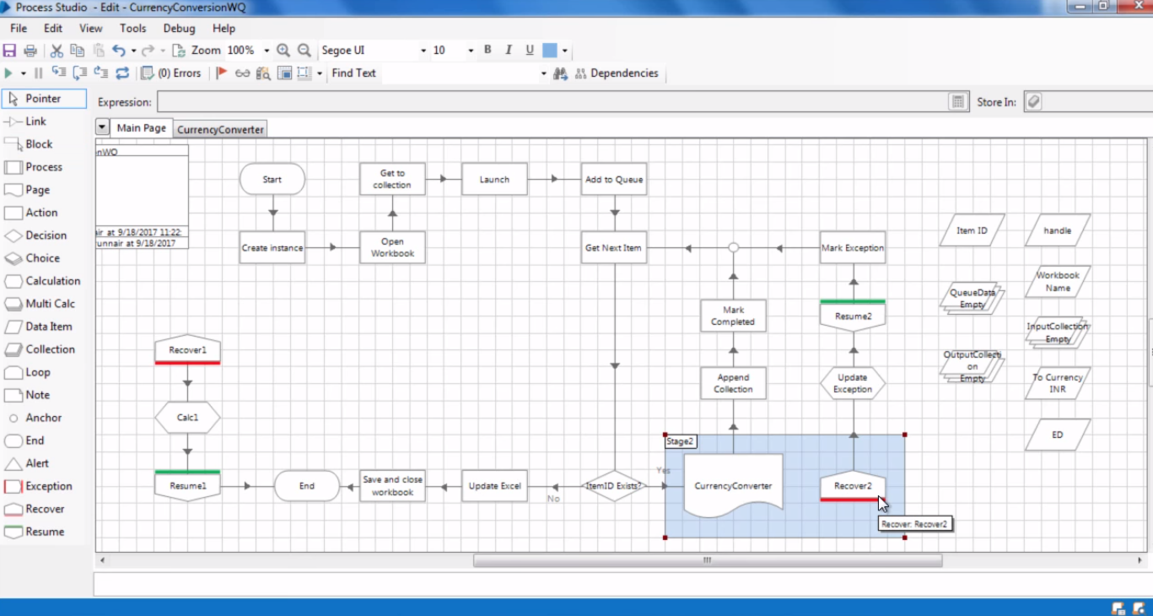

Here in above what we have done is we dragged a new pair of recover and resume stage and we enclosed new recover in block with currencyConvertor stage so if any exception comes up out of currencyConverter then this new recover block only will handle that.

We put calc stage with this recover block to get information about exception and store that in data item ED.

Then we used another action stage to mark exception if any exception comes up and follow path of recover stage.

The properties of all this stages are as given below –

Calc-

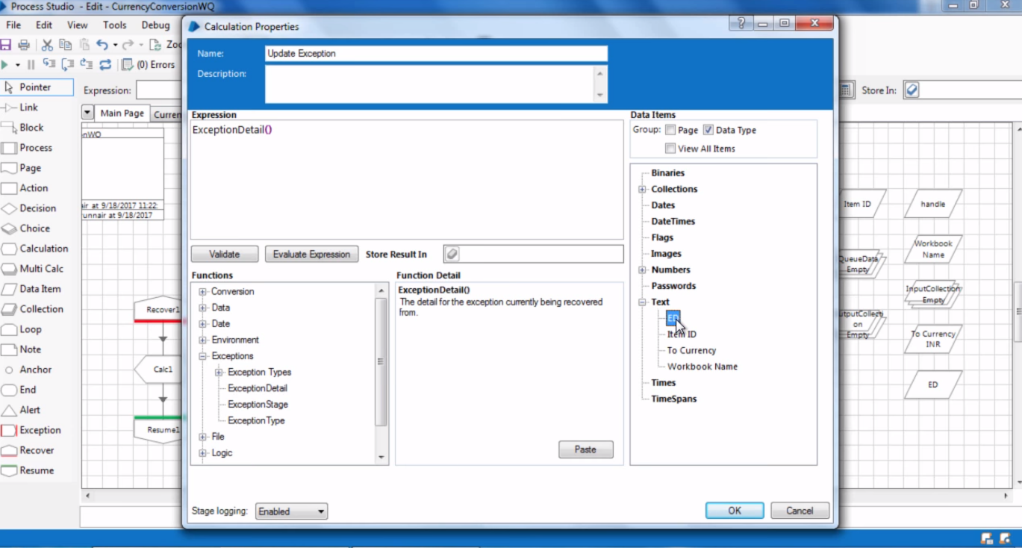

Store Exception details in **ED**-

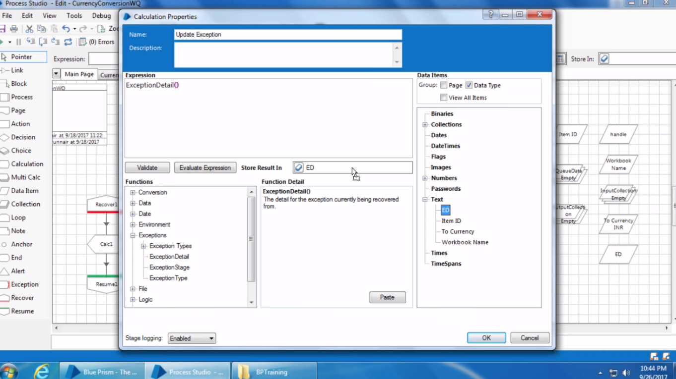

Mark Exception (Action stage )-

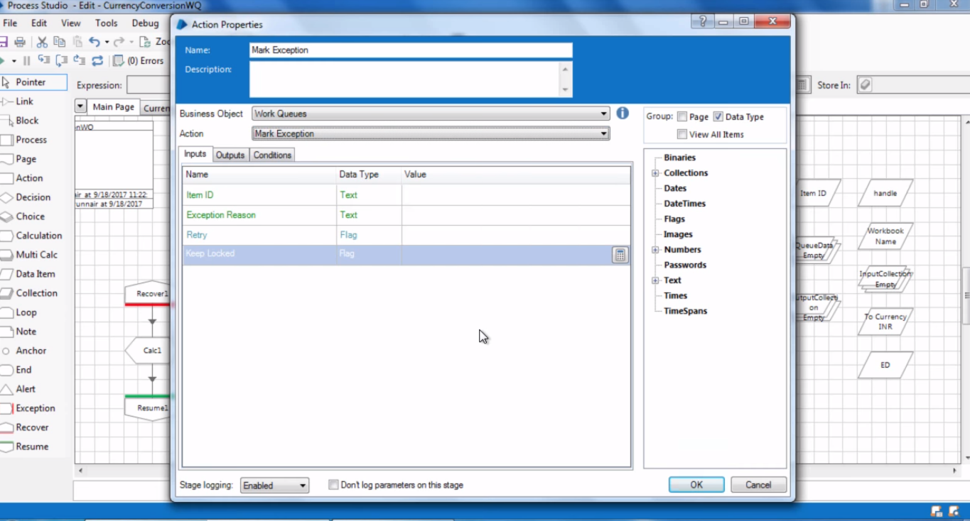

Provide ItemID and Exception details here as input parameter.

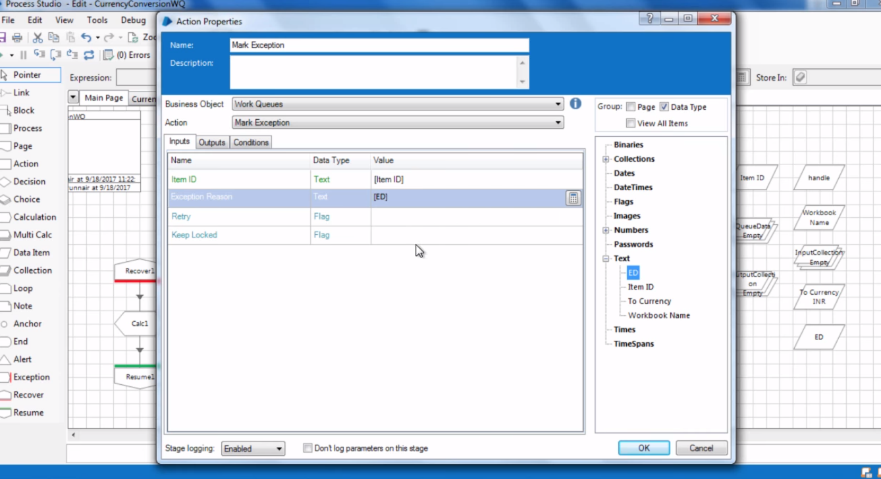

Now if any exception comes up. (Deliberately in this case now), will look like this in work Queue-

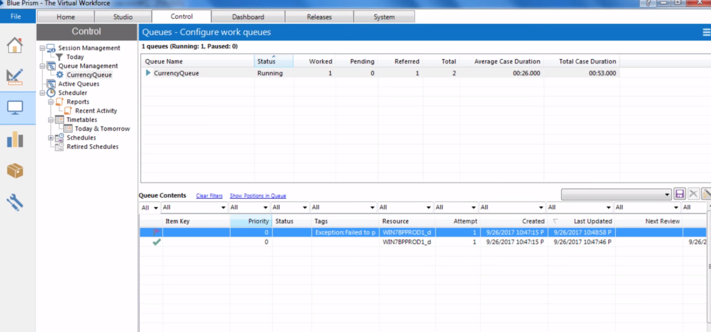

And see as the other record is processed successfully.

Exception record also contain information about the exception as below –

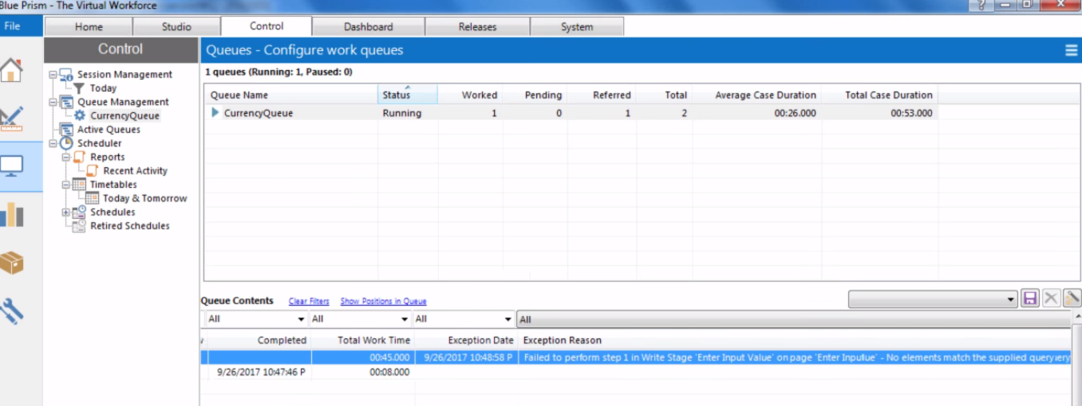

Now currently if we see queue records from work queue then we are unable to identify actually which record has been failed as the failed records do not show information about the actual field. Now in order to do so, so we can identify the failed records seeing from queue room only we can tag one of the field of the record with ITEM Key so that it shows the information about that column of that records watching which we can identify the record from queue room only.

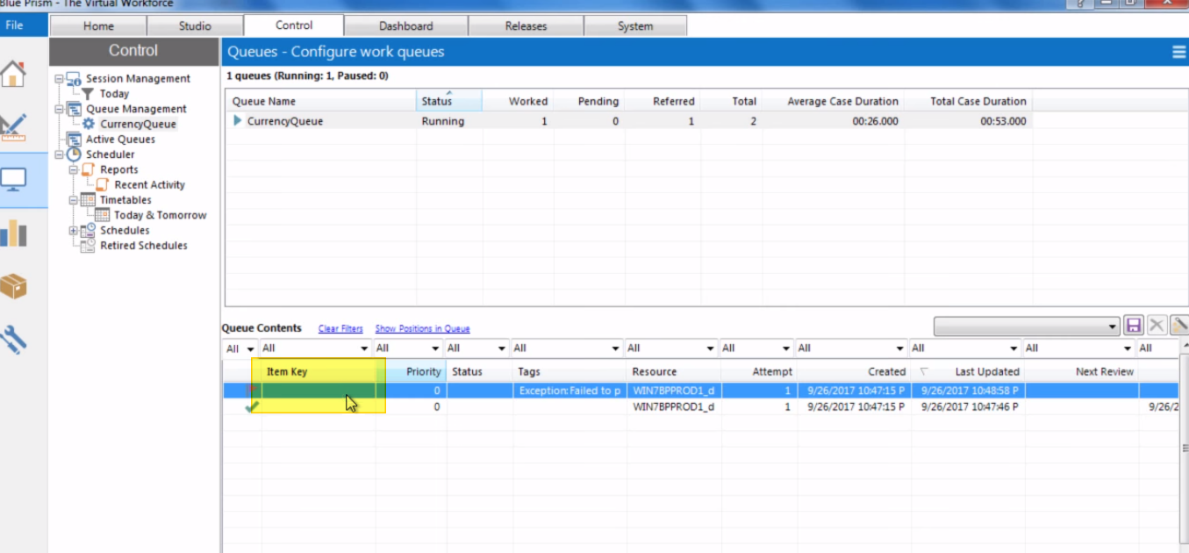

Now in order to configure any column for that, go to system > Workflow > Work Queue and there specify Field name in Key Name –

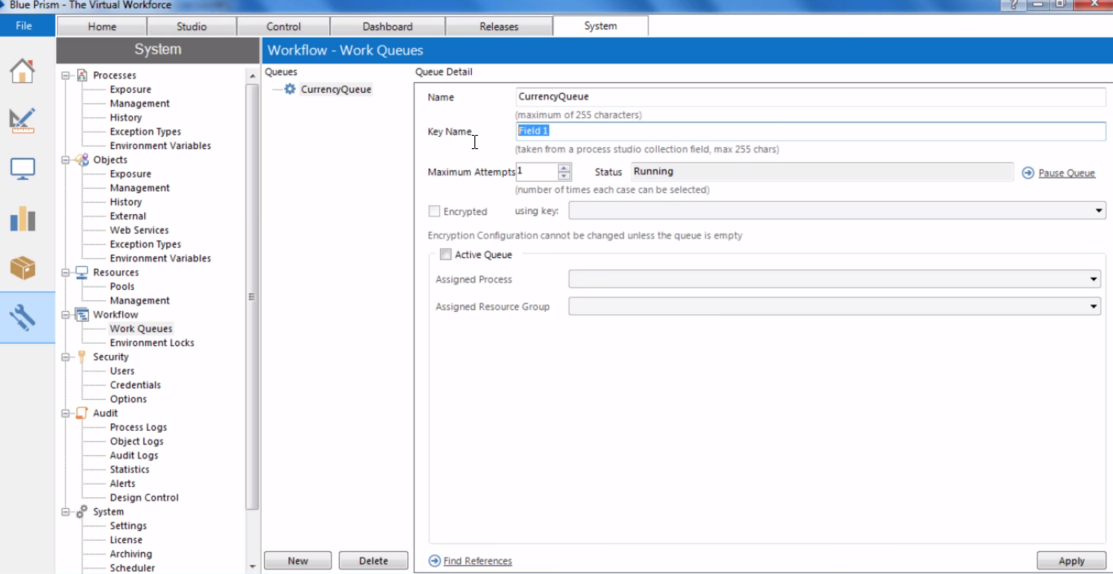

Now lets configure S.NO. field to this and if we ran again it so it shows s.no. number value at work room records.

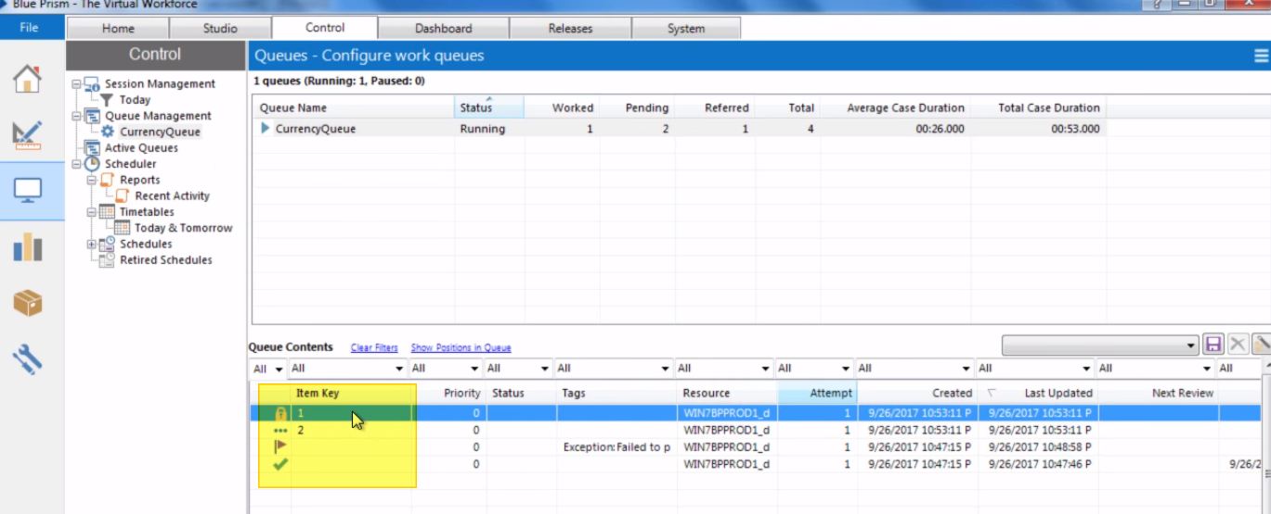

Now coming back to the workflow –

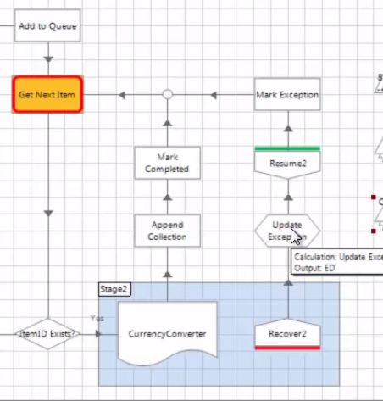Currently in this workflow if any exception comes in then it will not update queue data collection and output collection and will skip those from result.

Now suppose if we don’t want that and also want to include those failed records in the final excel.

The workaround for this is as given below –

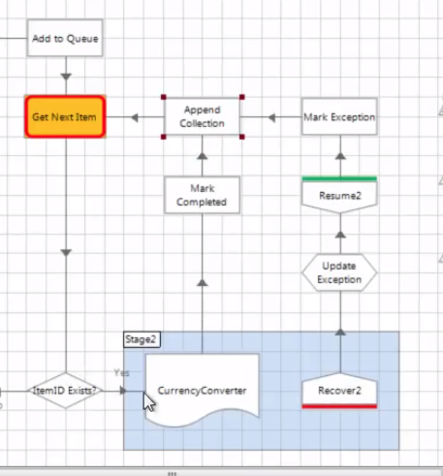

Now the final workflow would be as –

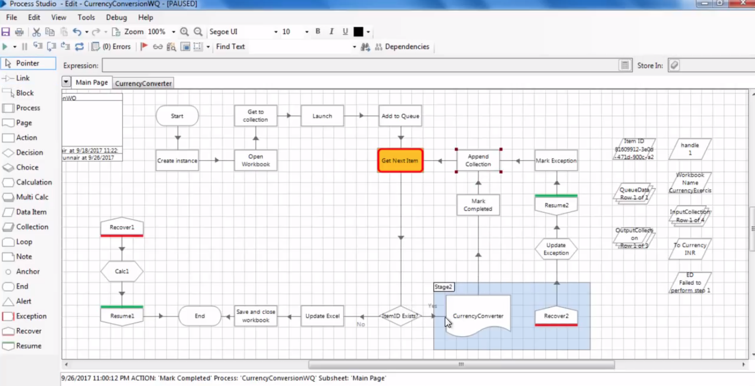

The only difference here is if it takes path of currency converter then INR value will be updated but it takes recover path then INR value will not be updated but in both cases the row will be append in final result.

# Exception Retry

Now let’s say if any exception comes up then we don’t want to mark it as exception but we want it to be retried few more times or specifically like 2 more times. How can we achieve that ?

We can configure that in maximum-attempt field in work Queue in system>workflow>work queue.

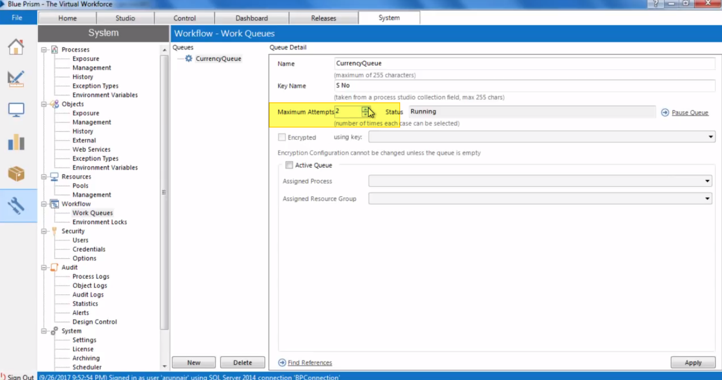

By default it’s 1 we can change it to 2 lets say.

Now what blue prism do here is, whenever any exception comes then blue prism makes copy of that records and insert it again in the work queue as a pending item.

Now let’s say if we insert two more records in our excel and ran the process again and we deliberately fail record 3 then this is how it seems in work queue control rooms –

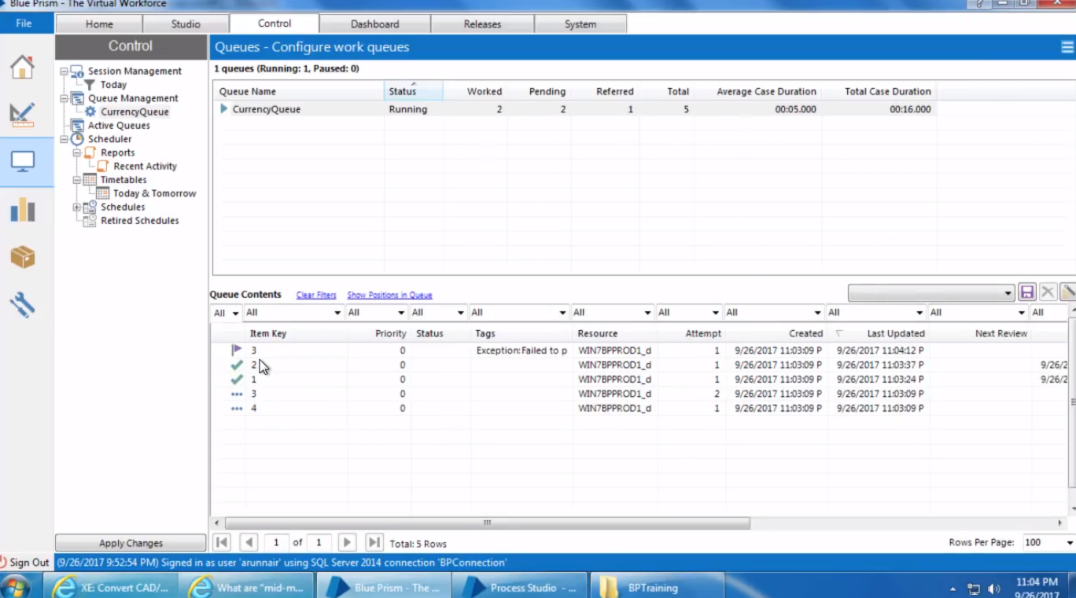

There is also a flag in mark exception action stage like below Retry Exception. If that is set to true then blue prism will retry in case of exception, if set to false then it will not retry in that case of an exception. (Default is True)

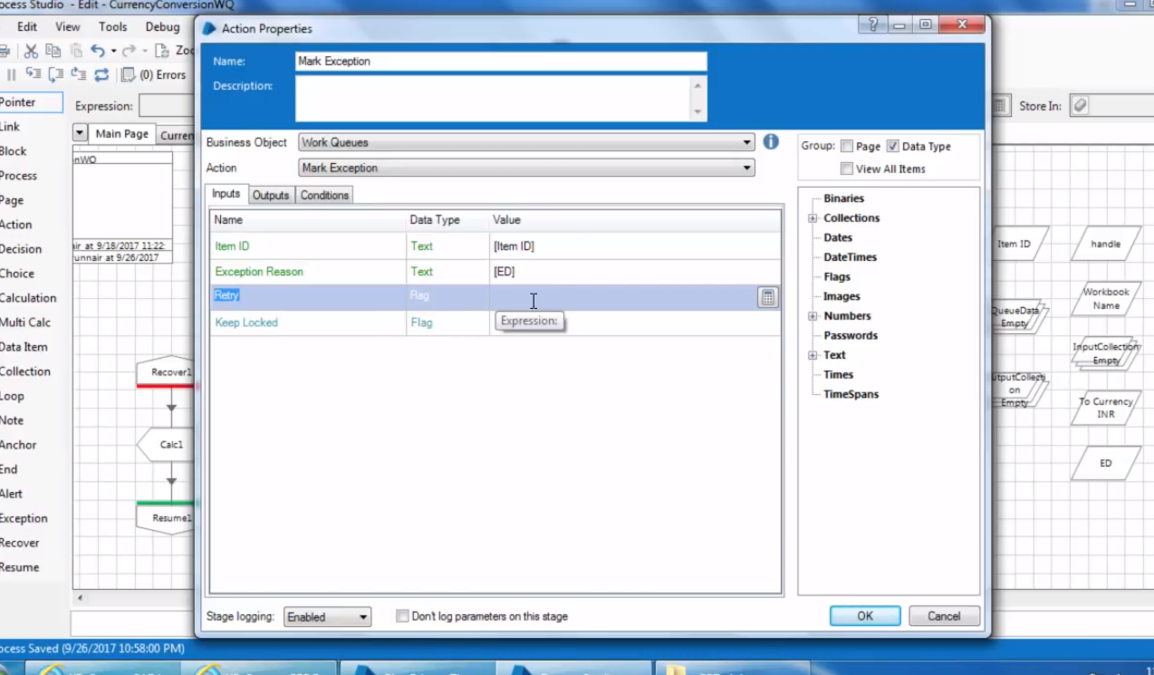

Now our final excel after execution looks something like this-

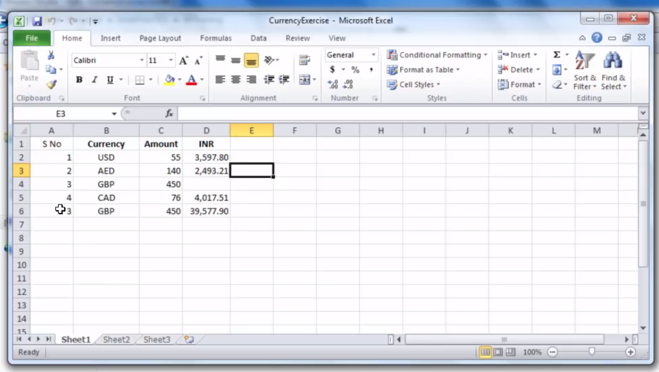

Here, there is an extra entry for record 3 and the sheet is not sorted in correct order.

Let’s understand the problem here,

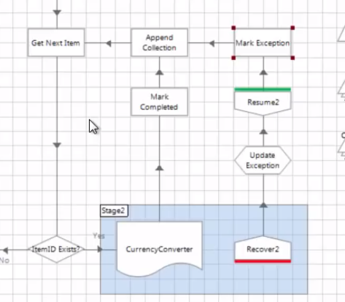When exception occurs the append collection stage append that record as well in outputcollection but blue prism in that case create a new copy of that record and insert that again as a new record in work queue. Hence it appears as a two record as first time we delibretely fail that record but next time we let it to be passed hence one record is present whose INR field is empty and one record is there whose INR field is filled.

Now how can we achieve to solve this problem and include only the final attempt here.

One possible solution may be like - we include a decision stage between append collection and mark exception stage which checks if the attempt number is equal to 3 or any maximum attempt number, if that is not equal to the maximum attempt number then we directly go to GET next item stage and skip append collection stage. And in case if that is the final attempt then we go through append collection stage and update that record in our final result.

But how do we obtain attempt number.. so for that open Get Next Item and output para you will the attempt number-

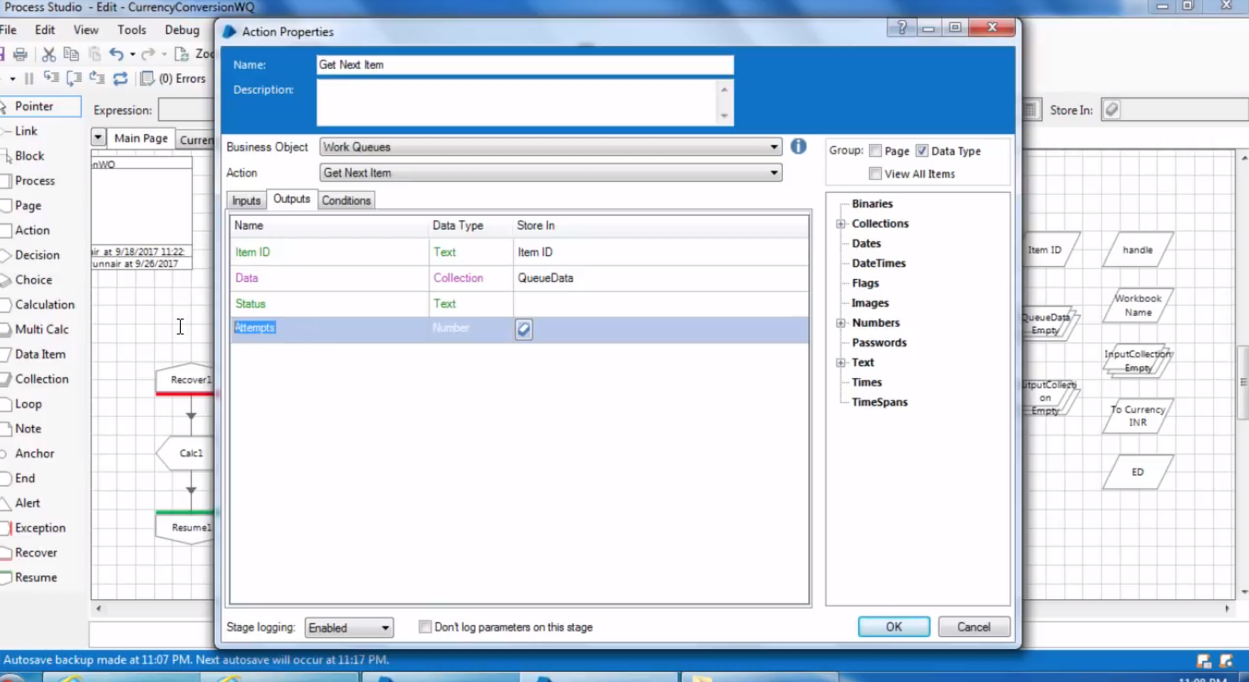

And to sort collection, right after the Item ID Exists? Stage and before update excel stage we add a new stage to sort the output collection.

# Multi BOT-Architecture-

When we need to process large volume of data in short period of time then one machine may not be sufficient hence in that case multi bot architecture comes into picture.

Let’s see the blueprism architecture –

In the most common scenarios, there would be a dedicated database server which other computers will be using on which blue prism will be installed. But instead of directly connecting to the data base server, the more efficient way for connection is to connect a Blue prism server to the dedicated database server and that blueprism server would be connected to the different blueprism clients. In that case, our data base server will not be exposed to all and would be secure.

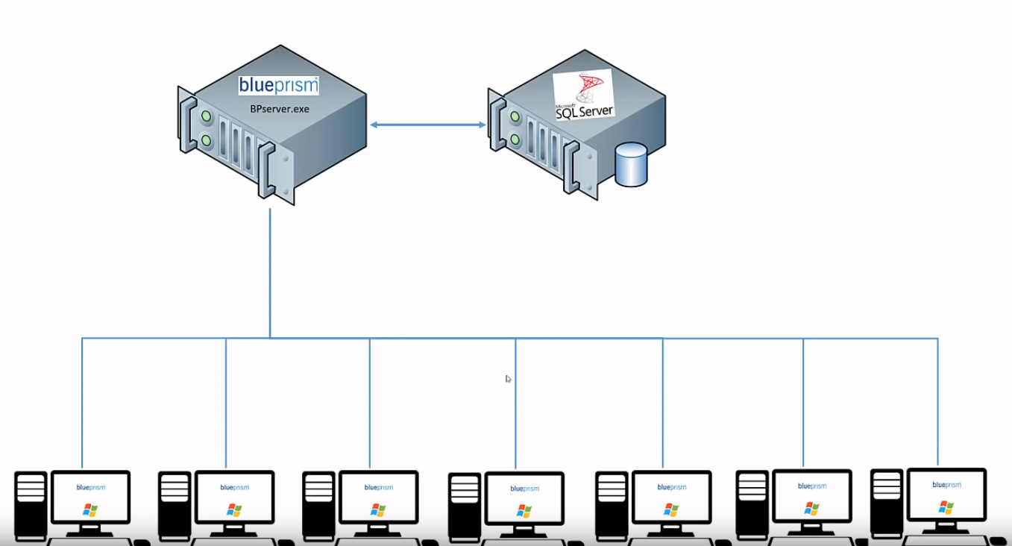

It may also happened in real time scenario that instead of 100 physical machines installed with blue prism client we may have one machine running multiple VM.

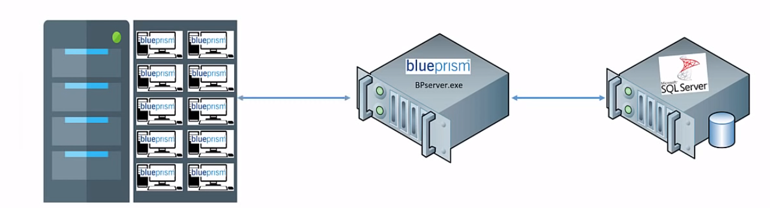

Now in order to setup multi bot architecture all the computers/VM should be in same network/IP-range.

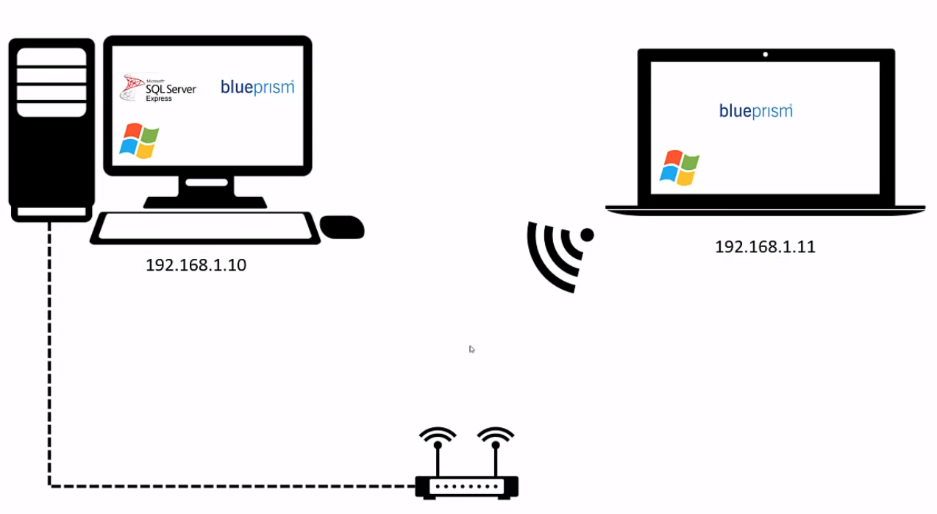

Let’s say we have master computer that has blue prism application server installed on it and also acts as an blue prism client as well.

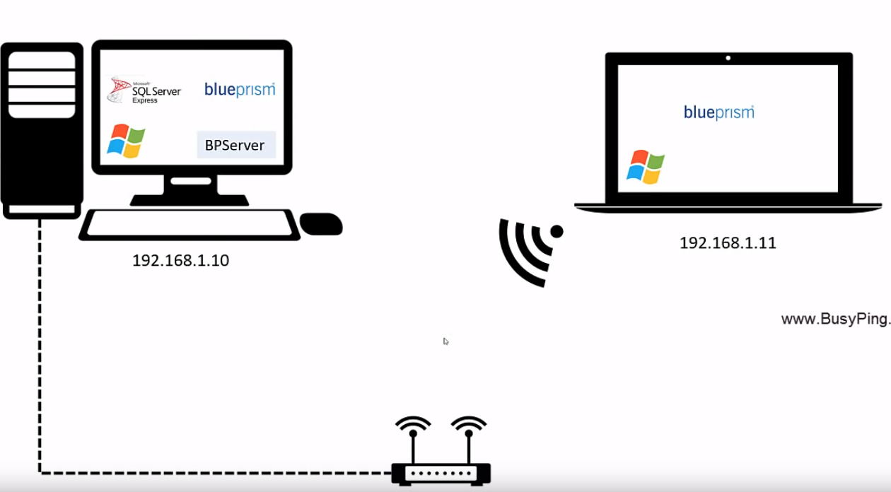

Now in order to setup a multi-bot architecture, and before setting up the server component, we first need to setup encryption key which primarily used to support the credentials manager.

Now in order, to do that, go to System > Security > Credentials

It basically allows us to save credentials of various applications with which blue prism interacts with. Now when we give credentials of various applications blue prism will encrypt these credentials using an encryption scheme which is needed to be configured.

To do that –System > Security > Encryption

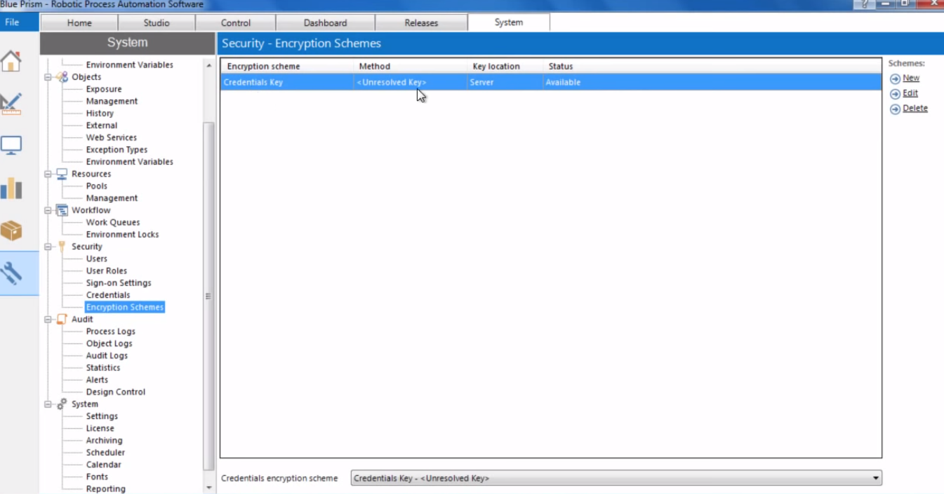

Cilck Edit-

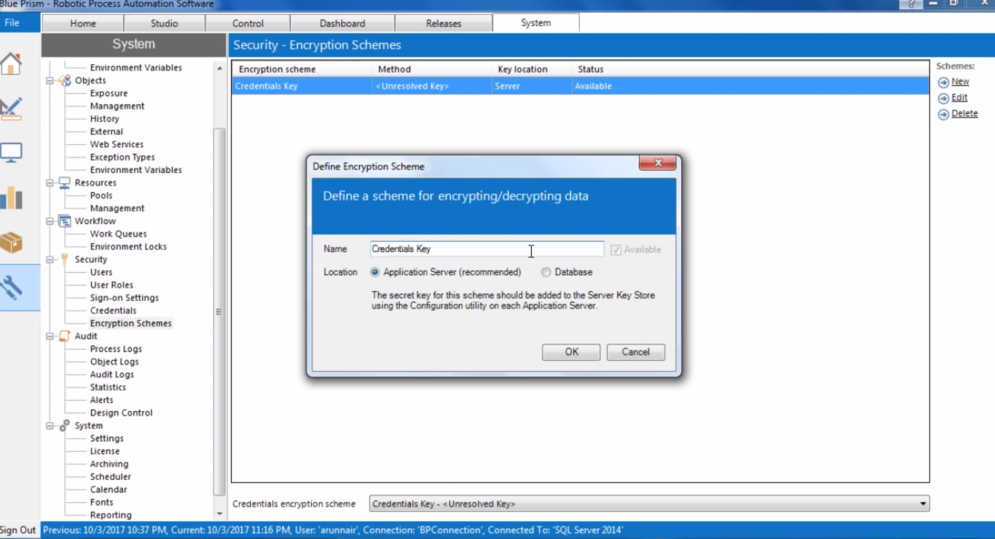

Select Database and Encyption scheme –

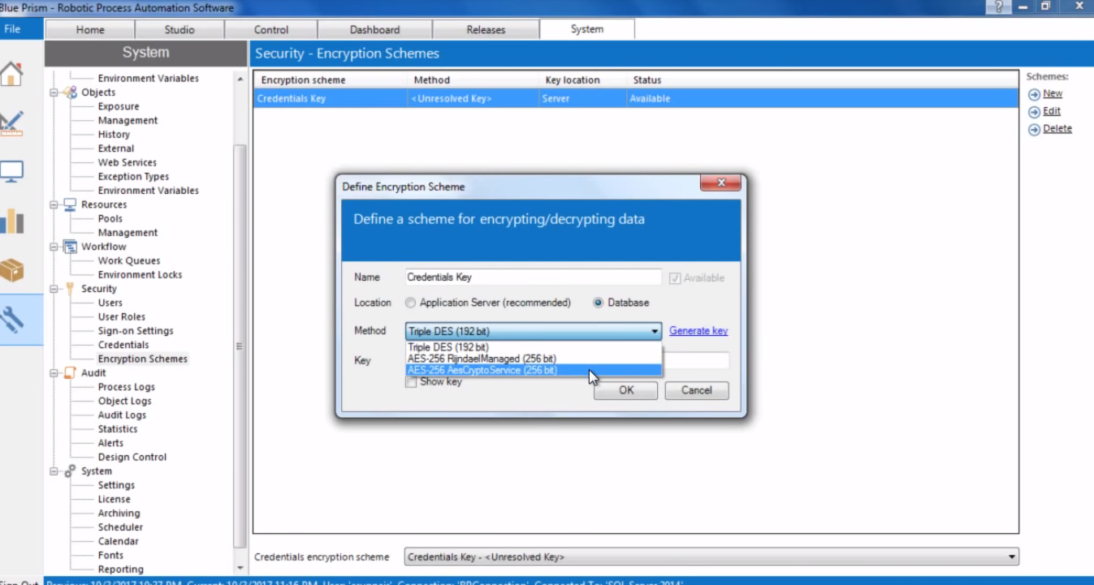

Click Generate Key-

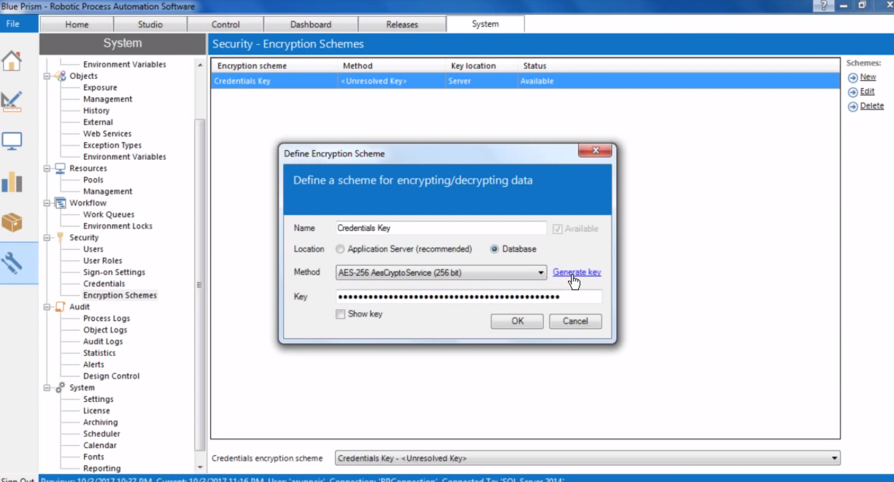

Click OK

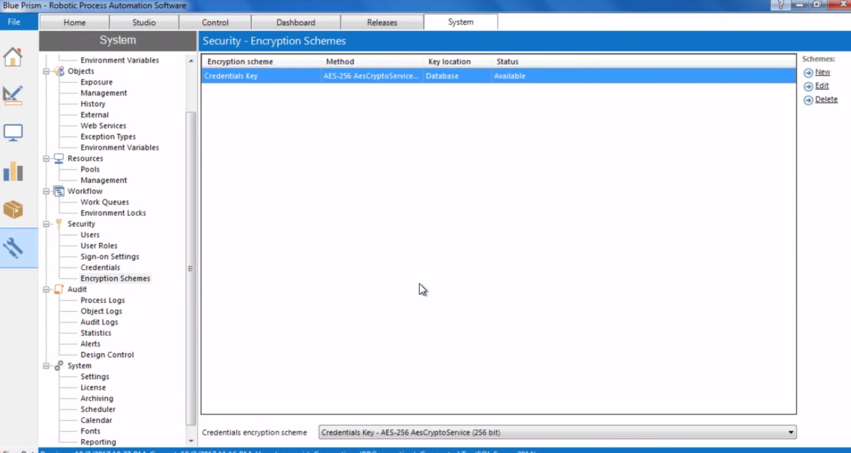

Now to setup BluePrism Application server.

Log-out of blue prism.

Open the BPserver from the path specified –

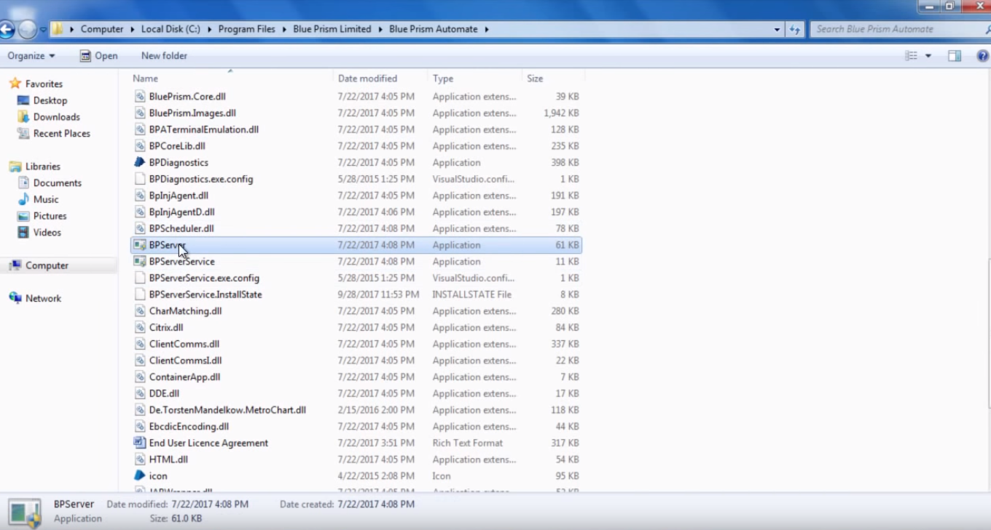

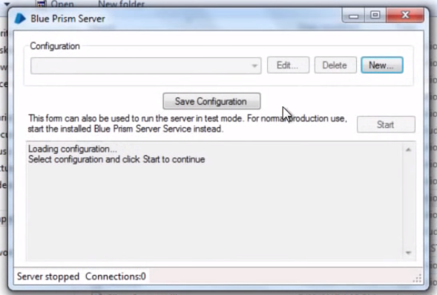

Click New-

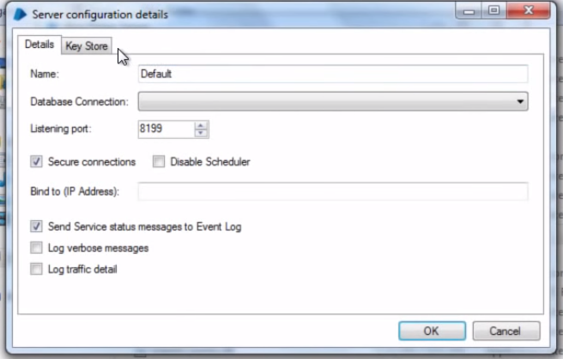

Goto Key Store-

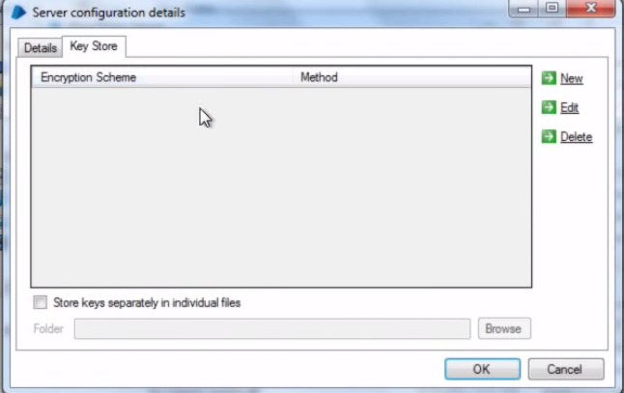

Click New –

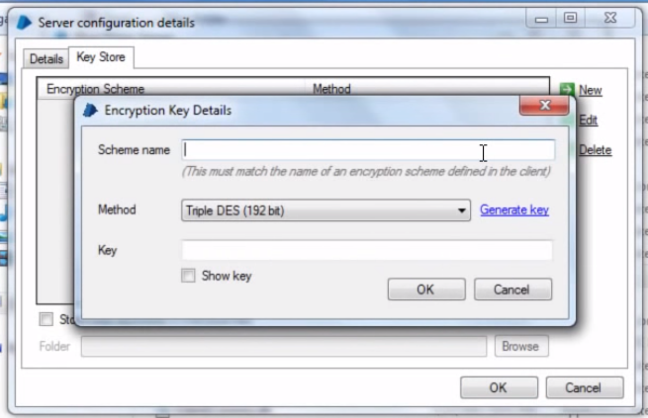

And supplied the same encryption scheme with same name as we supplied in earlier stage.

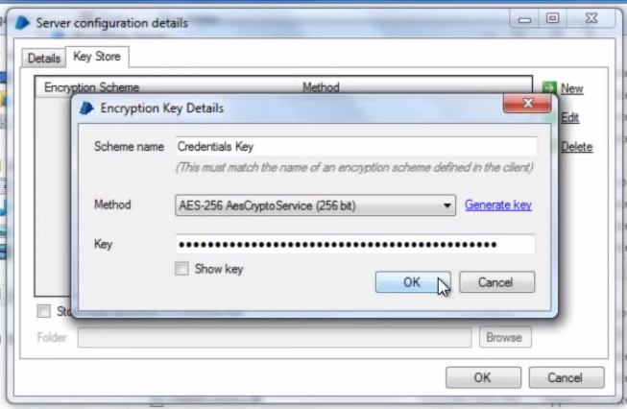

Come to details and keep the name as default-

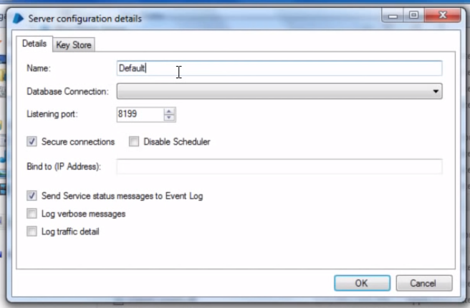Do not change the name from default to anything else here. As when blue prism installed, it register a service with name as bpserver in service.msc. with this instance name as default. If you change this name from here, then you will have to manually reconfigure or probably re install that service with the changed name.

Also uncheck Secure connection here, as that is been used in active directory architecture only.

Now click ok and save configuration.

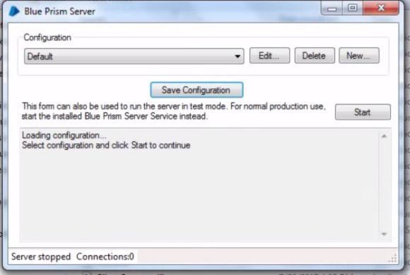Now after this we can start service by clicking on start here or by going to services.msc and start BPserver from there.

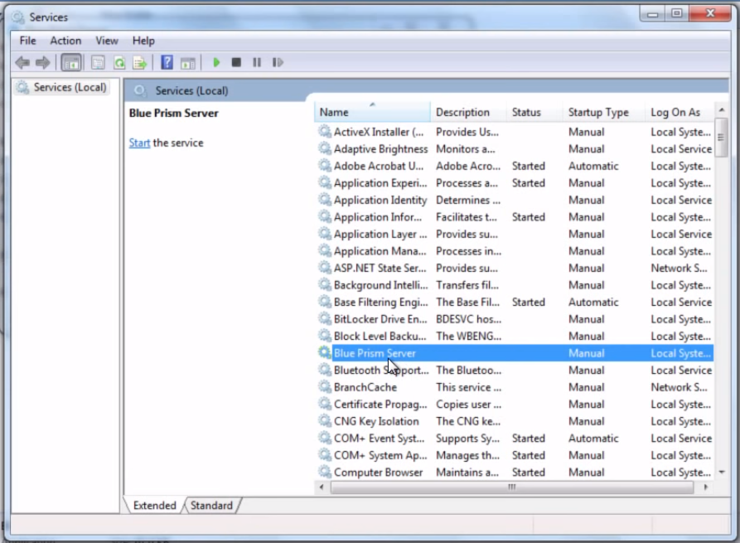But before starting the server from here we need to make some more configuration.

Open Blue Prism server properties and go to Log on tab.

Select here the account for authentication same as which is selected for database authentication. As

Lets say we selected sql server windows authentication then we select the same credentials here as well.

Now to do that select this account, click browse and type your windows user name and click check.

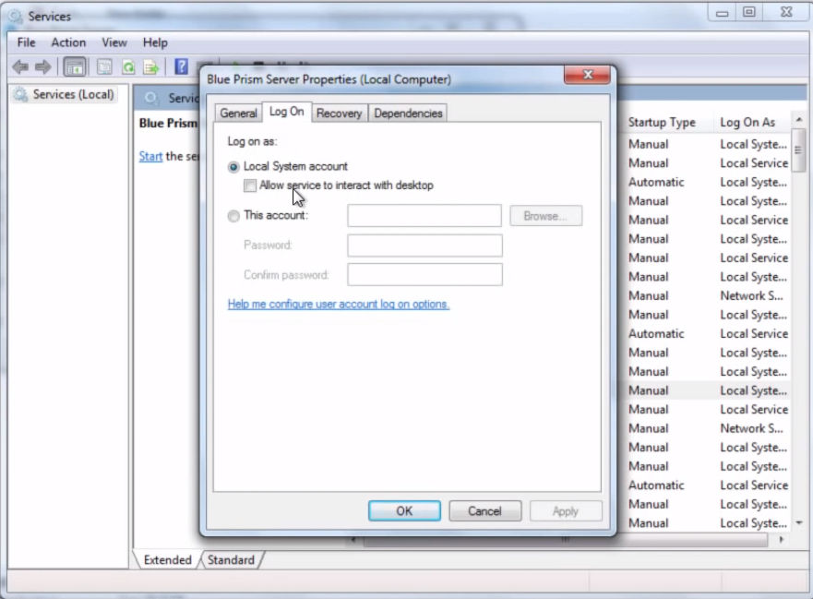

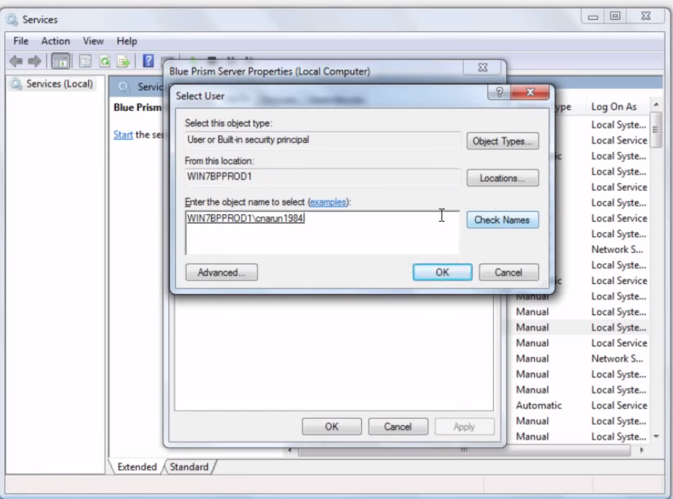

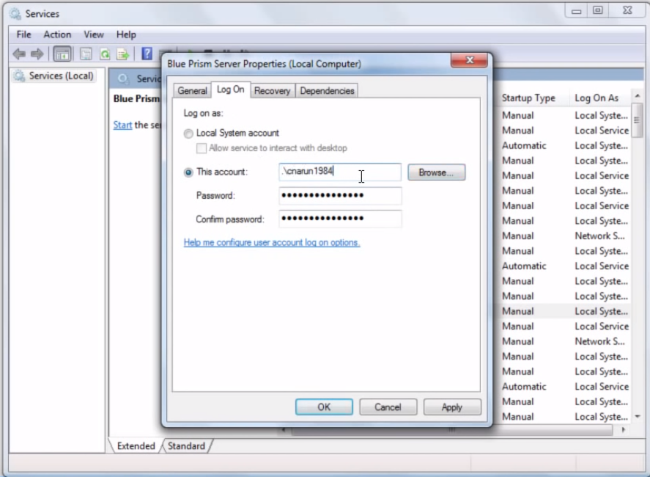

This says blue prism to use local system account along with windows authentication to interact with database as well.

Now click ok and start the service.

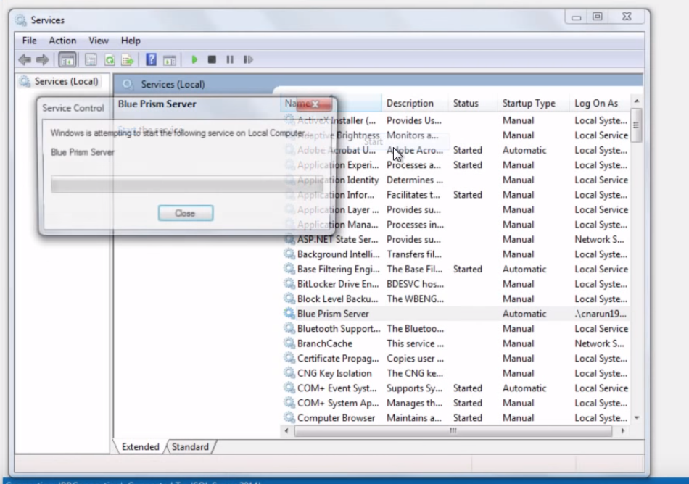

Now lets connect blue prism client – comp-1 and comp-2 to this application server.

First find the ip address of this server computer lets say 192.168.249.132 in this case.

Now open blue prism client computer. On login screen click configure –

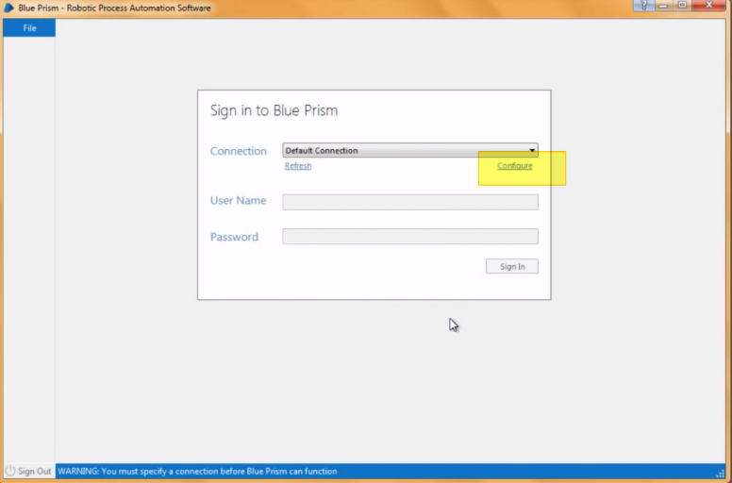it will open a new dialog. Select the below given settings to the field and provide IP address of the Blue Prism application server there. Uncheck Secure connection and login using the credentials here.

Credentials should be of the same account in which the process was created earlier.

Same credentials can be used for login on multiple computers.

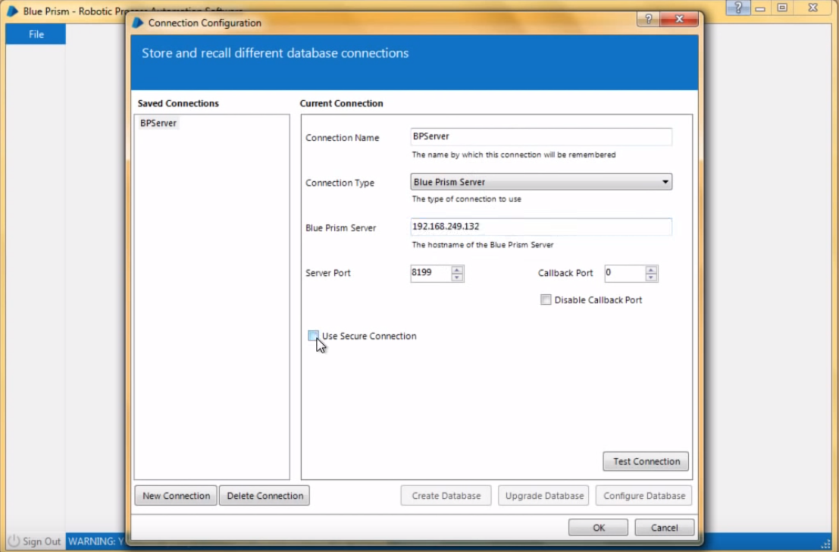

Now computer-1 is connected to Blue Prism Application server and loaded as a resource in resource section of control room.

Apply the same steps to connect multiple systems to this blue prism server. Let’s connect the another computer as well to this server. Now on any of the client now, in control room section you can see the list of the connected resources.

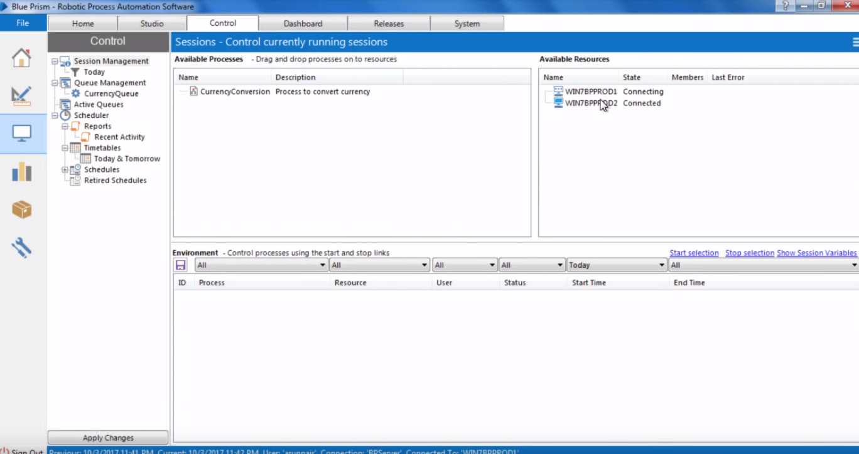

Now we can drag and drop the process from available process to resources or drag and drop resources to the process to assign resources to process and process to resources.

This is how the multi-bot architecture is setup.